CONSOLIDATED REPORT
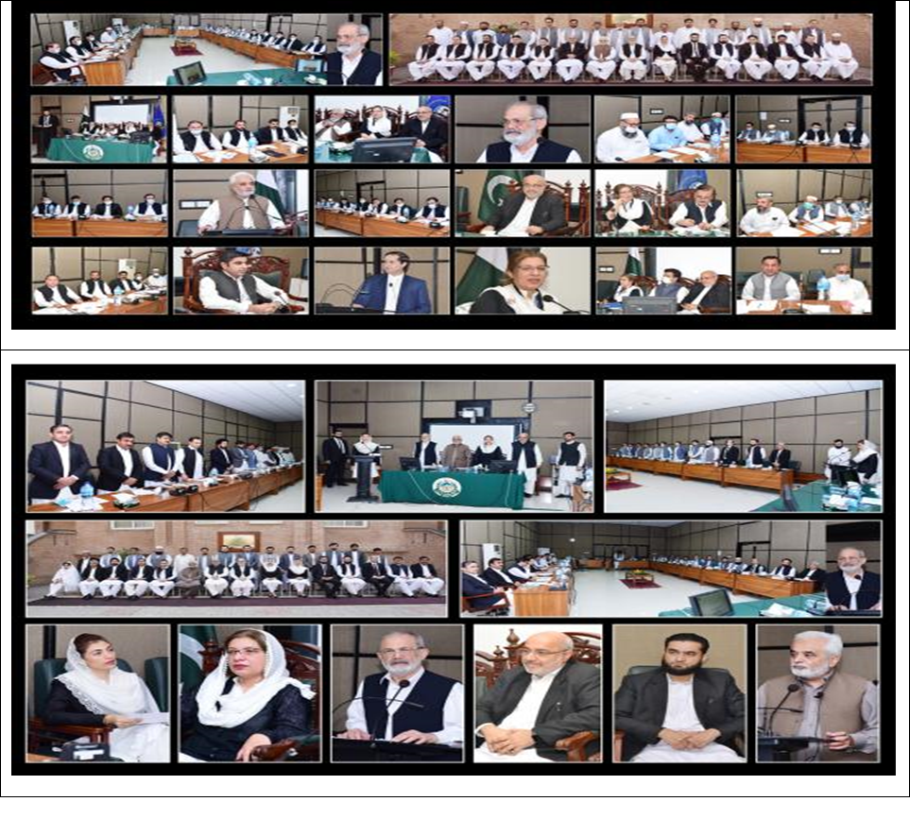
02-Day Training on Financial Management for Senior Civil Judges (Admn), Accountants, and Civil Nazirs of District Judiciary.

Prepared by:
Syed Yasir Shabbir (Director Instruction-I)
Finalized by:
Ms. Farah Jamshed (Dean Faculty)
Composed by:
Taimur Azam Khan (Assistant)
___________________________________________________________________________
Khyber Pakhtunkhwa Judicial Academy, Old Sessions Court Building, Jail Road, Peshawar

Contents
1.0 Introduction 1
2.0 Purpose of the report 1
3.0 Background 1
4.0 Participants 2
4.1 BATCH-I: 3
4.1.1 List of Participants 3
4.1.2 Group Photo 4
4.2 BATCH-II: 4
4.2.1 List of Participants 4
4.2.2 Group Photo 6
4.3 BATCH-III: 6
4.3.1 List of Participants 6
4.3.2 Group Photo 7
4.4 BATCH-IV: 8
4.4.1 List of Participants 8
4.4.2 Group Photo 9
5.0 Schedule of Activities 10
6.0 Proceedings 13
7.0 Impact of the training 14
8.0 Quality of the training 15
9.0 Conclusion 16

1.0 Introduction

1.1 The Khyber Pakhtunkhwa Judicial Academy (KPJA) is statutorily mandated to provide training to all justice sector stakeholders, to hold conferences, seminars, lectures, workshops and symposia in matters relating to court management, administration of justice, law and development of skills in legislative drafting and to establish liaison with research institutions, universities and other bodies including the Federal Judicial Academy, towards the cause of administration of justice (Section 4 of the Academy’s Act).
1.2 Capacity building in every field of judicial activity is a sine qua non for streamlining the system in its entirety. With this end in view, the Academy arranged 02- day trainings for Senior Civil Judges (Admn), Accountants, and Civil Nazirs of District Judiciary in four batches.

2.0 Purpose of the report

2.1 This report aims to assess the quality and impact of the training sessions delivered from 13th to 14th, 22nd to 23rd, 28th to 29th October 2021, and 03rd to 04th November 2021.
2.2 The report begins with a general layout of the training session including, training background, information about the participants, schedule of activities, and proceeding, followed by recommendations for future improvements.

3.0 Background
3.1 In the year 2020, for evaluation of the work of the Judicial Officers, an annual inspection was conducted by the Hon’ble Inspection Judges and the Principal Officers of the Peshawar High Court, Peshawar. Hon’ble the Chief Justice, Peshawar High Court, Peshawar was pleased to direct the principal officers, to sit with the Judicial Officers and conduct inspection in their presence also educating them to remove the deficiencies found in their courts and judicial work. Accordingly, the principal officers undertook a month-long hectic exercise and came up with their reports which were consolidated in the Annual Inspection Report 2020. The objective behind such inspection is to upgrade the standard of the district judiciary, especially to educate them thereby building their capacity.
The principal officers inspected the courts of Additional District & Sessions Judges, Senior Civil Judges, and Civil Judges/Judicial Magistrates and made assessments in accordance with already circulated proformas. They also observed some discrepancies. Of them, Financial Management was taken seriously notice of by the judicial leadership and instructed the Academy to devise a comprehensive module on Financial Management and arrange trainings for capacity building of the Senior Civil Judges, Accountants, and Civil Nazirs of district judiciary.
3.3 The objectives and learning outcomes of the program are as under:
3.4 Objectives
- To build the capacity of the trainees for better financial management;
- To sensitize them to the values of ethics and sense of self-accountability;
- To refine their professional skills for effective and efficient delivery of services;
- To motivate them towards exploring and utilizing tools for the achievement of organizational targets; and
- To equip them with the necessary skills.
3.5 Learning Outcome
- The trainees would be able to perform their duties with clarity, consistency, and confidence;
- They would be able to apply necessary skills and techniques for effective financial management; and
- They would be able to improve their soft skills.

4.0 Participants

4.1 List of participants of the trainings along with their designations and place of posting is detailed below:

4.1 BATCH-I:

4.1.1 List of Participants
DATED 13TH – 14TH OCTOBER 2021
S.# | Name | Designation | District
 | Mr. Muhammad Sher AliKhan | Senior Civil Judge | Peshawar
 | Mr. Abdul Salam Khan | Senior Civil Judge | Swat
 | Mr. Muhammad Shoaib | Senior Civil Judge | Mardan
 | Mr. Ijaz Ur Rehman | Senior Civil Judge | Shangla
 | Mr. Muhammad Hanif | Senior Civil Judge | Nowshera
 | Mr. Muhammad Irfan | Senior Civil Judge | Charsadda
 | Mr. Inam Khan | Senior Civil Judge | Swabi
 | Mr. Adam Khan | Senior Civil Judge | Malakand
 | Mr. Issa Khan Afridi | Senior Civil Judge | Dir Lower
 | Mr. Hazrat Nawab | Civil Nazir | Mardan
 | Mr. Yousaf Khan | Civil Nazir | Peshawar
 | Mr. Amer Muhammad | Civil Nazir | Malakand
 | Mr. Waqar Khan | Civil Nazir | Nowshera
 | Mr. Muhammad Ali | Civil Nazir | Charsadda
 | Mr. Sher Afsar | Civil Nazir | Swabi
 | Mr. Yousaf Khan | Civil Nazir | Swat
 | Mr. Qamar Zaman | Accountant | Shangla
 | Mr. Yousaf Khan | Accountant | Peshawar
 | Mr. Muhammad Saleem Khan | Accountant | Dir Lower
 | Mr. Ashfaq Alam | Accountant | Peshawar
 | Mr. Khalil Khan | Budget & Account Assistant | Peshawar
 | Mr. Inayat Ullah | Budget & Account Assistant | Malakand
 | Mr. Muhammad Sharif | Budget & Account Assistant | Nowshera
 | Mr. Fayaz Ali | Budget & Account Assistant | Charsadda
 | Mr. Sher Ali | Budget & Account Assistant | Swabi
 | Mr. Jamshid Muhammad | Budget & Account Assistant | Dir Lower
 | Mr. Falak Naz | Budget & Account Assistant | Swat
 | Mr. Zakir Ullah | Clerk of Court | Shangla

4.1.2 Group Photo

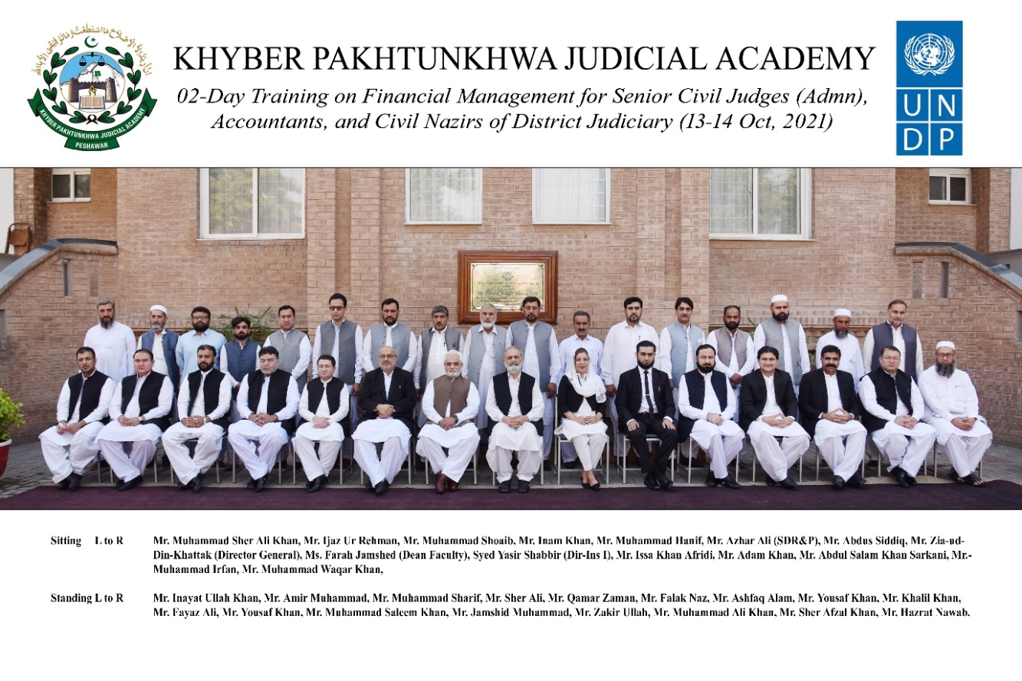

4.2 BATCH-II:

4.2.1 List of Participants
DATED 21st–22ndOCTOBER 2021
S.# | Name | Designation | District
 | Ms. Nadia Gul Wazir | Senior Civil Judge (Admin) | Buner
 | Ms. Nighat Bibi | Senior Civil Judge (Admin) | LakkiMarwat
 | Mr. Muhammad Wali | Senior Civil Judge (Admin) | Hangu
 | Mr. Iftikhar Ahmed | Senior Civil Judge (Admin) | Tank
 | Mr. Ghulam Hamid | Senior Civil Judge (Admin) | Lower Chitral
 | Mr. Ishtiaq Ahmed | Senior Civil Judge (Admin) | D. I Khan
 | Mr. Hussain Ali | Senior Civil Judge (Admin) | Kohat
 | Mr. Muhammad Jamil Khan | Senior Civil Judge (Admin) | Bannu
 | Mr. Atta ullah | Senior Civil Judge (Admin) | Dir Upper
 | Mr. Zahid Shah | Budget & Account Assistant | Hangu
 | Mr. Mahboob Elahi | Budget & Account Assistant | Lower Chitral
 | Mr. Riaz Mohammad | Budget & Account Assistant | Dir Upper
 | Mr. Ayaz Ali Shah | Budget & Account Assistant | Kohat
 | Mr. Hamid Khan | Budget & Account Assistant | Bannu
 | Mr. Muhammad Sardar Khan | Civil Nazir | Lawer Chitral
 | Mr. Muhammad Safi ullah  Khan | Civil Nazir | Bannu
 | Haji Zardar Khan | Civil Nazir | LakkiMarwat
 | Sardar Alam | Civil Nazir | Kohat
 | Mr. Noor Zamir | Civil Nazir | Hangu
 | Mr. Liaqat ullah | Civil Nazir | Tank
 | Mr. Umar Farooq | Civil Nazir | D. I Khan
 | Mr. Muhammd Usman Ghani | Accountant | D.I Khan
 | Mr. Taj Muhammad | Accountant | LakkiMarwat
 | Mr. Niaz Ali Khan | Accountant | Buner
 | Syed Sajjad Ali Shah | Clerk of Court | Dir Upper
 | Mr. Fazal Rahim | Clerk of Court | Lower Chitral
 | Mr. Samiullah | Clerk of Court | Tank
 | Mr. Rozi Gul | Clerk of Court | Buner

4.2.2 Group Photo
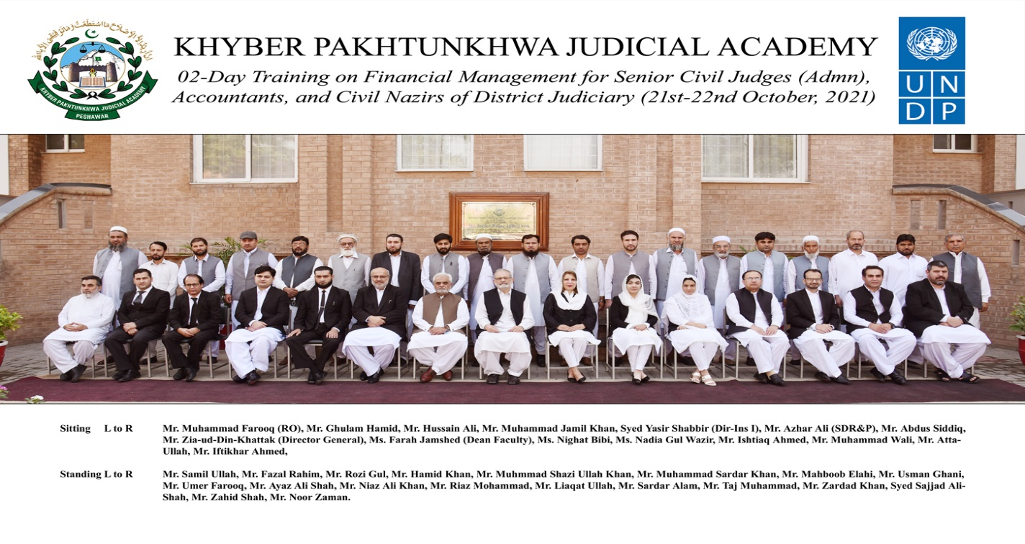
4.3 BATCH-III:

4.3.1 List of Participants
DATED 28TH – 29TH OCTOBER 2021
S.# | Name | Designation | District
 | Mr. Ijaz Younas | Senior Civil Judge | Kohistan at Dassu
 | Mr. Ishfaq Ahmad | Senior Civil Judge | Haripur
 | Mr. Shehzad Ali | Senior Civil Judge | Battagram
 | Mr. Islamuddin | Senior Civil Judge | KolaiPalas
 | Mr. Qaiser Shahzad | Senior Civil Judge | Tor Ghar
 | Mr. Sheraz Tariq | Senior Civil Judge | Abbottabad
 | Mr. Mohsin Abbas | Senior Civil Judge | Kohistan Lower
 | Mr. Abdul Hassan Mohmand | Senior Civil Judge | Karak
 | Mr. Khalid Anwar | Senior Civil Judge | Mansehra
 | Mr. Masood Khan | Civil Nazir | Mansehra
 | Mr. Ghulam Nabi | Civil Nazir | Upper Kohistan
 | Mr. Abdurur Rehman | Civil Nazir | Haripur
 | Mr. Naz Mohammad | Civil Nazir | Battagram
 | Mr. Hayat Khan | Civil Nazir | Abbottabad
 | Mr. Qasim Jan | Civil Nazir | KolaiPalas
 | Mr. IntikhabAlam | Budget & Account Assistant | Karak
 | Mr. Sheeraz Ahmad | Budget & Account Assistant | Mansehra
 | Mr. Tahir Mehmood | Budget & Account Assistant | Haripur
 | Mr. Ghulam Rasool | Budget & Account Assistant | Battagram
 | Mr. Sajid Ahmad | Budget & Account Assistant | Abbottabad
 | Mr. Alam Zeb | Budget & Account Assistant | KolaiPalas
 | Mr. Bilal Ahmad | Budget & Account Assistant | Tor Ghar
 | Mr. Raz Ali Khan Khattak | Clerk of Court | Karak
 | Mr. Muhammad Azeem | Assistant | Lower Kohistan
 | Mr. Umar Farooq | Assistant | Tor Ghar
 | Mr. Muhammad Ismail | Assistant | Tor Ghar
 | Mr. Shah Faisal | Assistant | Lower Kohistan

4.3.2 Group Photo
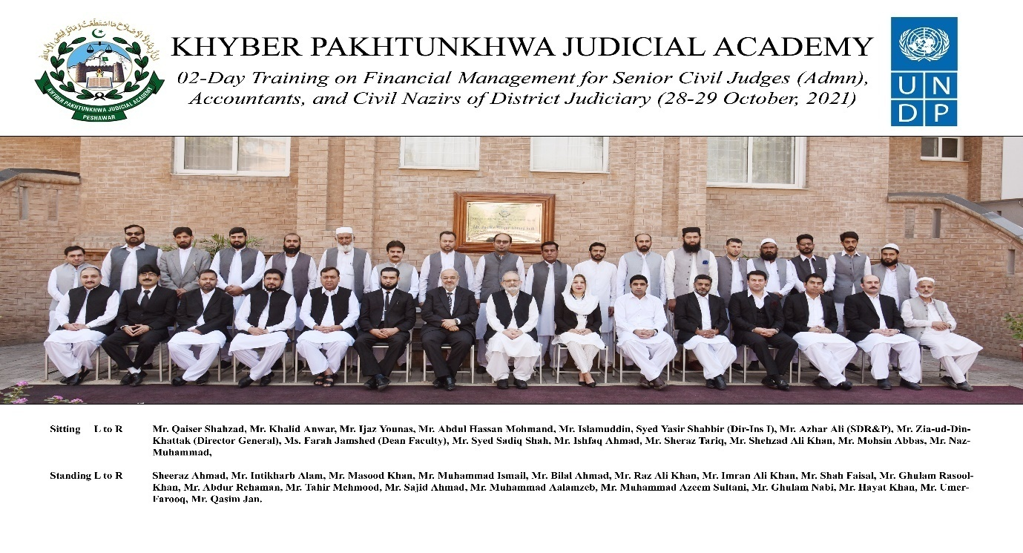

4.4 BATCH-IV:

4.4.1 List of Participants
DATED 03-04 NOVEMBER, 2021

S.# | Name | Designation | District
 | Mr. Tanveer Usman | Senior Civil Judge | Chitral Upper
 | Syed Israr Ali Shah | Senior Civil Judge | Mohmand
 | Mr. Najeeb-ul-Haq | Senior Civil Judge | Bajaur
 | Mr. Arshad Khan Afridi | Senior Civil Judge | N.Waristan
 | Mr. Farman Ullah | Senior Civil Judge | Orakzai
 | Mr. Qaiser Khan Afridi | Senior Civil Judge | Kurram
 | Mr. Imranullah | Senior Civil Judge | Khyber
 | Mr. Akbar Ali | Senior Civil Judge | S.Waziristan
 | Mr. Zubair Wazir | Civil Nazir | N.Waziristan
 | Mr. Shams-ur-Rehman | Civil Nazir/ Clerk of Court | Kurram
 | Ms. Makia Bibi | Civil Nazir | Khyber
 | Mr. Dilawar Khan | Civil Nazir | Bajaur
 | Mr. Tahir Khan | Civil Nazir | Mohmand
 | Mr. Sher Ahmad Khan | Naib Nazir | Chitral Upper
 | Mr. Mazhar Masood | Budget & Accounts Assistant | S.Waziristan
 | Mr. Muhammad Junaid | Budget & Accounts Assistant | Khyber
 | Mr. Naheed Ali | Budget & Accounts Assistant | Orakzai
 | Mr. Abdul Khaliq | Budget & Accounts Assistant | N.Waziristan
 | Mr. Shaukat Hussain Orakzai | Budget & Accounts Assistant | Kurram
 | Ms.RashidaMenhaz | Accountant | Chitral Upper
 | Mr. Muqeem Shah | Budget & Accounts Assistant | Mohmand
 | Mr. Abdur Rahman | Budget & Accounts Assistant/Junior Clerk | Bajaur
 | Mr. Burhan ud din | Clerk of Court | S.Waziristan
 | Syed Muhammad Ayaz | Clerk of Court | Orakzai

4.4.2 Group Photo
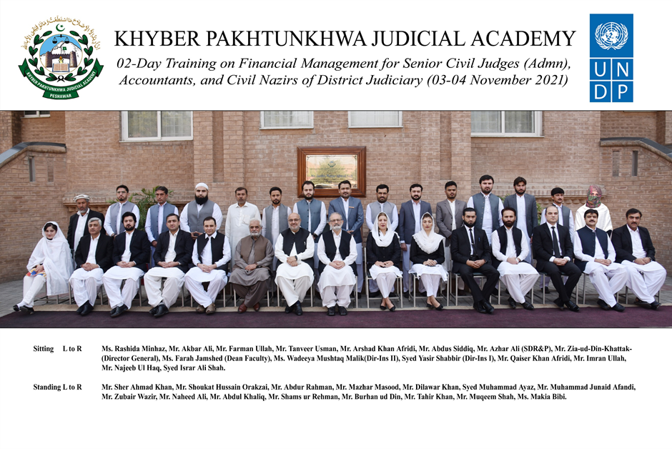

5.0 Schedule of Activities

5.1 Schedule of Activities is detailed as: -
Group-I: 13th – 14th October 2021,
Group-II: 21st-22nd October 2021,
Group-III: 28th-29th October 2021, and
Group-IV: 03rd-04th November 2021.
Day – 1:
S.# |  | Activities |  | Resource Person | Duration
1.1 |  | Inaugural Ceremony  - Registration & Pre-Evaluation  - Recitation from the Holy Quran  - National Anthem |  |  | 08:30-09:00
1.2 |  | Welcome Address / Orientation |  | Director General | 09:00-09:10
1.3 |  | Group Photo |  |  | 09:10-09:15
1.4 |  | General Financial Rules – I  - General Responsibilities of SCJs as DDOs  - Supervising Expenditure  - Service Books  - Budget, Grants and Appropriates (GfR.62 - 94)  - Receipts and Payment of Public Money (GFR 26 - 38)  - Contracts Procurement and Stock Taking (GFR 141-174)  - (KP Public Procurement Rules, 2014)  - Power of Sanction (GFR 39 - 61)  - (KP Delegation of Financial Powers Rules, 2018)  - Permanent Advance  - Establishment (GFR 93-123)  - Preparation and Submission of Claims (GFR 32)  - Fixation of Pay  - Mode of Payment  - Government Accounts and its Reconciliation (GFR 326) |  | Mr. Abdus Siddiq,  Former Director General Audit, KP/Financial Consultant, KP Revenue Authority | 09:15-10:45
 |  | Tea Break 10:45 - 11:15
1.5 |  | General Financial Rules – II  - Audit  - Internal  - External  - Defence of Audit Paras  - Assets Management  - TA & Transfer Grants  - Pay & Advance  - Leave Rules  - Book Keeping  - Computation of Claims  - Leave Pending Retirement(LPR)  - GP Fund Advance & Adjustments |  | Mr. Altaf Hussain, Internal Audit Specialist, SDJ, PHC | 11:15-12:45
Prayer & Lunch 12:45 - 01:30
1.6 |  | Budget Management  - Functions of DDO Relating to Budget  - Budgetary Plan  - Budget Classification  - Budgetary Process  - Expenditure and Receipt management & Reconciliation  - Effective Utilization of Budget  - Statement of Excess and Surrender supported by justification  - Supplementary Budget Statement  - Authentication of Budget  - Re-appropriation of Funds  - Recording of Disbursement by DDO |  | Syed Sadiq Shah, Director Budget & Accounts, PHC | 01:30- 02:30
Day – 2 :
 |  | Recitation from the Holy Quran |  |  | 08:55-09:00
2.1 | Judicial Accounts  - Sherriff’s Petty  - Revenue Deposits( Current Accounts & Civil Court Deposits)  - Peshawar High Court Rules & Orders, Vol-II, III & IV  - Important Registers  - Personal Ledger Account( PLA)  - Cash Book  - Deposit & Withdrawal Procedure  - Limits of Cash in Hand  - Reconciliation  - Responsibilities of Civil Nazir  - Judicial Fines  - Collection  - Rules regarding timely deposit  - Consequences of delayed deposit |  |  | Mr. Adil Khan D&SJ/Judge ATC,Peshawar/Mr. Muhammad Zeb Khan D&SJ,PSO to HCJ/Mr. Amjad Zia Siddiqui D&SJ/ Judge Consumer Court Chitral | 09:00 -10:45
Tea Break 10:45 - 11:15
2.2 |  |  | Public Procurement  - General Principles of Public Procurement Framework  - Procurement Need Assessment  - Procurement Planning  - Procurement of Goods, Works & Services  - Procedure of Invitation of Tenders  - Competitive Bidding  - Contract Administration & Monitoring  - Redress of grievances | Mr. Muhammad Qasim , Director Capacity Building ,PPRA/ Mr. Jehanzeb Pervaiz Legal, Advisor Public Finance Management, KP. | 11:15-12:45
Prayer & Lunch 12:45 - 01:30
2.3 |  |  | Planning and Development  - Importance of Planning  - High Court Share in Annual Development Plan  - Types of Expenditure  - Developmental Works, Maintenance & Repairs  - PC-I & PC -IV | Mr. Ashfaq Taj D&SJ, Peshawar/Mr. Abdul Haleem Bangash Director P&D, PHC /Mr. Rafiq Jan,  Deputy Director P&D, PHC | 01:30-2:30
2.4 |  |  | Concluding Ceremony  - Post Training Evaluation  - Class Representative Remarks  - Wrap up/ Certificate Distribution |  | 02:30  Onwards

6.0 Proceedings

6.1 Registration and Pre-Evaluation: Before formal commencement of the activities, registration of the participants and their pre-training evaluations were conducted.
6.2 Inaugural Ceremony: All trainings commenced with an inaugural ceremony chaired by Mr. Zia-ud-Din Khattak, Director General, Khyber Pakhtunkhwa Judicial Academy. In his address, the Director-General extended a welcome to the participants. He congratulated them upon their selection for this course. He also offered special thanks to the resource persons for sparing time out of their busy schedules and coming to the Academy for discourse. He gave a concise introduction of Financial Management and briefly explained the background of the training besides its objectives and learning outcome. He advised the participants to make every effort so that they should have a gainful utilization of this training time and go well equipped with adequate knowledge, information, and tools for the performance of their duties.
6.3 Lectures Synopsis
6.3.1 Mr. Abdus Siddiq, Former Director General Audit, Khyber Pakhtunkhwa/Financial Consultant, Khyber Pakhtunkhwa Revenue Authority, and Mr. Altaf Hussain, Internal Audit Specialist, Secretariat of District Judiciary, Peshawar High Court, Peshawar, delivered separate lectures on General Financial Rules. They referred relevant rules and regulations to bring home the importance of financial management. They spoke extensively on their allocated modules.
6.3.2 Mr. Sadiq Shah, Director Budget & Accounts, Peshawar High Court, Peshawar, delivered lectures on Budget Management. His discourses focused on the functions of DDO relating to Budget; Budget Classification; Budgetary Process; Expenditure and Receipt management & Reconciliation; Effective Utilization of Budget; Statement of Excess and Surrender supported by justification; Supplementary Budget Statement; Authentication of Budget; Re-appropriation of Funds and Recording of Disbursement by DDOs.
6.3.3 Mr. Muhammad Adil Khan D&SJ/Judge Anti-Terrorism Court, Peshawar, Mr. Muhammad Zeb Khan D&SJ, PSO to Hon’ble the Chief Justice, Peshawar High Court, Peshawar, and Mr. Amjad Zia Siddiqui D&SJ/ Judge Consumer Court, Chitral made their respective presentations on Judicial Accounts. The learned resource persons appraised the participants on the delicate nature of the subject. They focused on the knowledge and skills required for judicial accounts maintenance and the need for clarity, honesty, and transparency in fiscal matters.
6.3.4 Dr. Muhammad Qasim, Director Capacity Building, Public Procurement Regulatory Authority, delivered lectures on Public Procurement. He apprised the participants about the basic principles of public procurement.
6.3.4 Mr. Ashfaq Taj, District & Sessions Judge, Peshawar, Mr. Abdul Haleem Bangash, Director P&D, PHC, and Mr. Rafiq Jan, Deputy Director P&D, PHC, delivered their respective lectures on Planning and Development. They highlighted the historical perspective of the share of the Hon’ble Peshawar High Court in the Annual Development Plan. They also explained the requisite procedure for developmental works, repair, and maintenance of the official buildings.
6.4 Post-Evaluation: On the last day of the training, the post-training evaluation of each batch was conducted.
6.5 Concluding Ceremony: Each training concluded with a concluding ceremony presided over by the Director General; the class representative shared his/her views and appreciated the efforts made by the Academy. In the end, the Director General awarded certificates to the participants.

7.0 Impact of the training

7.1 Significant indicator of the training impact is:
7.1.1 Whether the training contributed to an increase in the knowledge of the participants?
7.1.2 Whether that will translate itself into a practical utility?
The pre & post-evaluation questionnaire was designed to deal with this aspect. The relevant feedback obtained from the participants is reflected below:
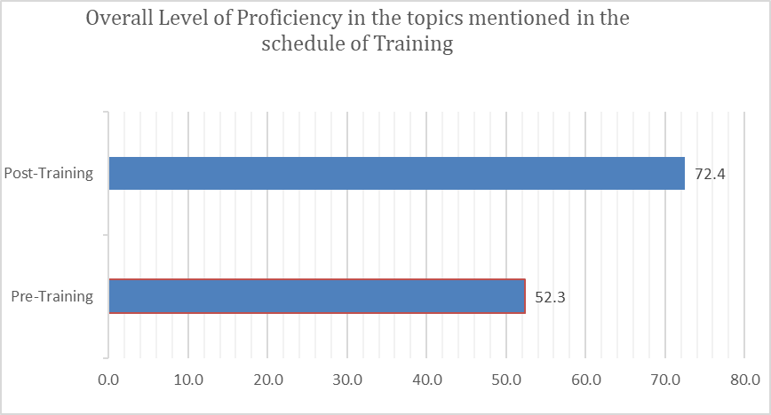

8.0 Quality of the training
8.1 The quality of the training can be assessed by the participants’ evaluation of the resource persons. Moreover, the participants were asked to comment on the overall quality of the training program. Their response and the feedback are shown in graphic form below:
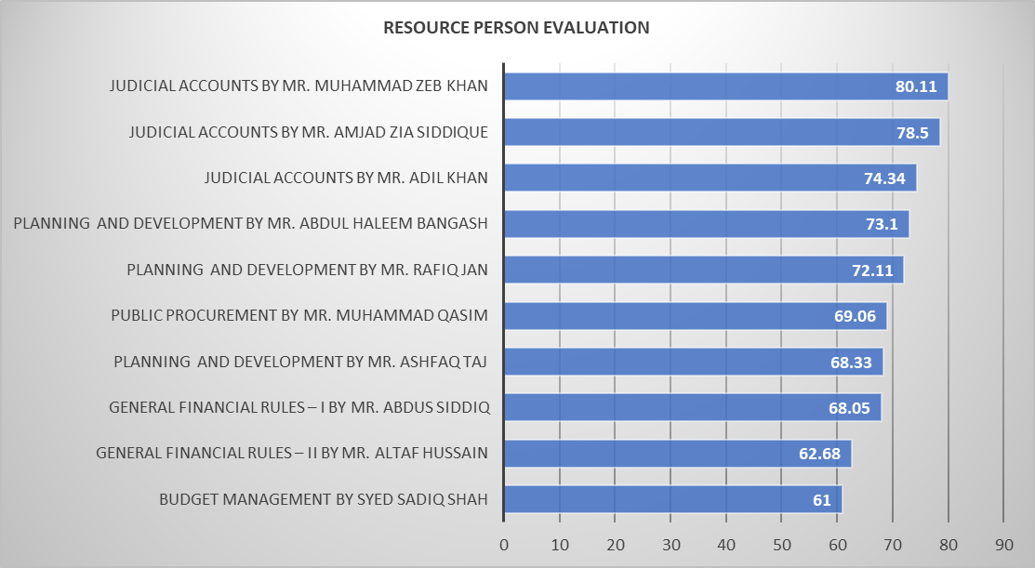
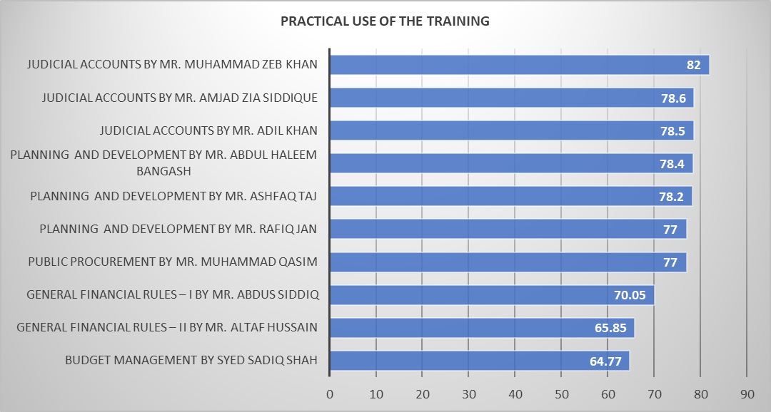
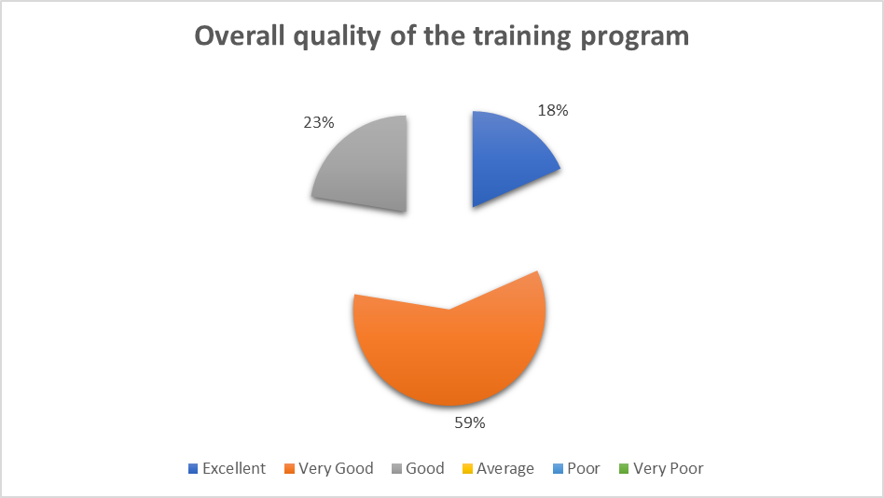

8.2 The general comments of the participants regarding the training summarized by the class representative are as under:
- Overall, the training was well-designed and comprehensive.
- Duration of lectures may be increased
- Course duration may be extended to at least one week
- Other ministerial staff including Naib Nazir from Tehsils may be imparted the subject training
- Subject training may be rolled out annually for DDOs and allied staff of District Judiciary
- Frequent refresher courses and such like trainings may be conducted
- Practical/ mock exercises on preparations of budget, procurement etc may be included in future trainings.

9.0 Conclusion

9.1 Participants' graphical feedback indicates that the training's performance and effect have been rated very good.
9.2. Based on the participants' feedback, training modules can be further improved.
9.3. The trainees review reflects the achievement of training objectives.

