REPORT
One Day Consultative Workshop on Civil Case Management Rules
February 09, 2019
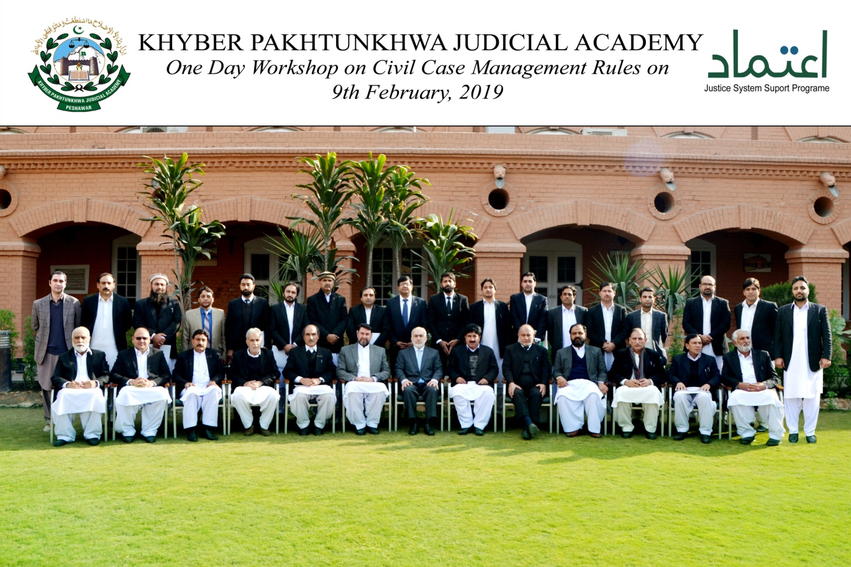
Prepared by:
Dr. Shakeel Azam Awan (Dean Faculty)
Ahmed Iftikhar (Director Instructions)
______________________________________________________________________________Khyber Pakhtunkhwa Judicial Academy, Old Sessions Court Building, Jail Road, Peshawar
info@kpja.edu.pk | www.kpja.edu.pk

Introduction

  - KPJA is statutorily mandated to provide training to all justice sector stakeholders, to hold conferences, seminars, lectures, workshops and symposia in matters relating to court management, administration of justice, law and development of skills in legislative drafting and to establish liaison with research institutions, universities and other bodies including the Federal Judicial Academy, towards the cause of administration of justice. (Section 4 of the Academy Act)
  - On 23.01.2018 Peshawar High Court notified various amendments in first schedule of CPC with far reaching consequences. Broadly signified as civil case management rules, they were the product of extensive deliberations by the Administration Committee of the Peshawar High Court.
  - In the month of November 2018 Peshawar High Court organized regional trainings on the new rules. The ultimate objective was to improve understanding of the new rules and thus to gain maximum utilization out of the same.
  - Treading further, it was considered necessary to develop Monitoring and Evaluation Mechanism and thus the idea to hold the workshop. No less significant was the concern raised by the lawyers on the enforcement of the rules.

2.0 Purpose of the report

2.1 This report aims to assess the impact of the workshop held on 9th February 2019.
2.2 The report begins with information about the participants, followed by summary of the sessions, views of the lawyers and the recommendations.

3.0 Participants
3.1 Participants of the session were the lawyers. Since resentment against the rules mostly came from lawyers of Malakand region, their maximal possible participation was ensured. Invitation was extended to Presidents of all districts bar associations, President Peshawar High Court bar association, Vice chairman K.P bar council, Presidents of all circuit benches of the High Court. President district bar association Swat had also been asked for 10 nominees of his choice. Table below, describes in detail, the names of participants.
S. No | Name | Designation
1 | Mr. Ahmed Ali | Advocate D.B.A Swat
2 | Mr. Salman Hayat | Advocate D.B.A Swat
3 | Mr. Zarawar Khan | Advocate D.B.A Swat
4 | Mr. Asmat Ali | Advocate D.B.A Swat
5 | Mr. Shah Roome | President D.B.A Malakand
6 | Mr. Zahid-ul-Haq | President D.B.A Bannu
7 | Mr. Abdul Haleem | President D.B.A Swat
8 | Mr. Qaiser Ali | Member D.B.A Swat
9 | Mr. Iftikhar Tanooli | V.P D.B.A Abbottabad
10 | Mr. Kifayar Yar | President D.B.A Dir Lower
11 | Mr. Javed Akhtar | President D.B.A Dir Upper
12 | Mr. Siraj Rabbani | V.P D.B.A Chitral
13 | Said Jamil Shah | President D.B.A Buner
14 | Mr. Asad Ullah | President D.B.A Haripur
15 | Mr. Awais Ibrahim | Secretary D.B.A Haripur
16 | Mr. Javed Akhtar | President D.B.A Kohat
17 | Mr. Hassan Khan | President D.B.A Hangu
18 | Mr. Saeed Usman | President D.B.A Mardan
19 | Malik Danyaz | President D.B.A Swabi
20 | Mr. Hayat Khan | V.P D.B.A Charsadda
21 | Mr. Noman | Advocate D.B.A Swat
22 | Mr. Fayaz Ali | Advocate D.B.A Swat
23 | Mr. Nasir Khan | Advocate D.B.A Swat
24 | Mr. Ishtiaq Khan | Advocate D.B.A Mansehra
25 | Mr. Waqas Khan | Advocate D.B.A Swat
26 | Mr. Arshad Ali | Advocate D.B.A Swat
27 | Mr. Saeed Khan | Vice Chairman KP Bar Council
28 | Mr. Arshad Ali | Advocate D.B.A Swat
29 | Mr. Fayaz Khan | President High Court Bar Association

Summary of Session 1
4.1 Dean KPJA hosted the session. Session began with the recitation of Holy Quran. DG KPJA then welcomed the participants. He highlighted the background and objectives of the workshop.
  - Mr. Zia-ur-Rehman Director Instruction delivered presentation on,”Civil Case Management Rules”.

  - In his presentation he, explained;
- Reasons attributable to delayed delivery of justice.
- Lack of control of proceedings by the trial judge.
- History of case management rules in different countries and benefits obtained there from.
- Mode and manner for applicability of Order 10 to 15 CPC and its utility.
- Scope of summary judgment.

5.0 Summary of Session 2
5.1 Second session was an open house discussion, comprising views of bar members, officers of the Academy and Q&A. Mr. Ahmed Iftikhar Director Instruction and Mr. Zia-Ur-Rehman Director Instruction moderated the session. Following are key highlights of the session.
5.2 Views of Vice President DBA Abottabad
- 98% of lawyers are happy with the enforcement of Civil Case Management Rules. The remaining 2% lawyers are non-practicing.
- Responsibility of Judges has increased with new rules. Therefore recruitment mechanism of the Judges is to be improved with active practice of 02 years.

5.2 Views of President DBA Bannu
- ”Justice hurried is Justice buried”, may not be ignored in chase of “Justice Delayed, Justice Denied”.
- Before making the new rules, lawyers should have been taken on board.
- Emphasis should be on training on legal ethics and if that doesn’t solve the problem of frivolous litigation, sec 35A CPC may be invoked.
- When pleadings are verified on oath, examination of parties will be waste of time.
- Two main reasons are attributable to delays in trials. One is the non-appearance of official witnesses summoned through court and the other is trust deficit between judges and lawyers. The lawyers have been wholeheartedly extending support in expeditious disposal of cases, whenever the judges themselves wanted to do so. The implementation of the case management rules will be possible if the lawyers are not over burdened.
- According to resolution of the bar, the enforceability of the rules should be suspended.

5.3 Views of President DBA Kohat
- Bar has passed a resolution for suspension of the enforcement of the rules and therefore enforcement of the rules should have been suspended in anticipation of present discourse.
- The prime reason for delay in conclusion of civil cases is the inefficiency of process serving agency.
- Although after the lecture of Mr. Zia-Ur-Rehman Director Instruction, many ambiguities stood cleared, yet there are some more questions that boggle the mind.
- Is every miscellaneous application at trial stage barred? If not conceptual clarity be imparted to the judges.
- No right of appeal or revision against orders is unjust, particularly in temporary injunctions. It would be appropriate to open remedy of revision at least.
- If the new rules are all about proper implementation of Order 10 to Order 15 CPC, what was the necessity of making new rules?

5.4 View of President HCBA Mingora
- The initiative taken by Academy to remove misconception of case management rules is commendable and this was the opportune moment to do so. When the Judges started applying case management rules, rift was created between bench and the bar. On the one hand in appeals /revision against interlocutory orders judges raised questions of maintainability in the light of new rules, whereas the lawyers on the other hand protested against their very implementation and strikes were declared. In making criminal case management rules proper procedure is being followed by inviting maximum number of lawyers in the seminar. Had this procedure been followed for making civil case management rules, there would have been no conflict at all.
- There are number of parts in the case management rules which are commendable. There are however some on which lawyers have reservation.
- When Provincial Bar Council got to know that there was resentment of the lawyers of different areas against the implementation of case management rules general body meeting was called. And on 19th January unanimous resolution was passed against the rules. The general body meeting was attended by almost all the important office bearers of the Bar.
- If in appeals pending against interlocutory orders, the case management rule are invoked that will lead to rift between the lawyers and judges. In order to prevent that situation, it is suggested that letter be addressed to the Provincial Bar Council, asking for comments of the lawyers on the case management rules. The said letter should be sent by the Provincial Bar Council, to all District Bar Councils, Tehsil Bar Associations, Sub divisional Bar Associations and High Court Bar Association, for views of the lawyers. This is to be followed by internal meetings of the bar. Based on the recommendations in the said meetings Presidents of respective Bar Associations be invited for a final meeting to ascertain views of the Bar. If in the said meeting, the reservations are entertained on some portions, the same are to be communicated to the KPJA, for onward transmission to the Rule Making Committee. Till such time, implementation of case management rules should be stopped.
5.5 Views of President D.B.A Buner
- Lawyers have unanimously passed resolution against the implementation of Case Management Rules.
- If the object is to curtail time in conclusion of cases, the procedure prescribed by Nizam-e-Adl Regulation should be followed.
- One of the prime reason for delay in conclusion of cases is that same party is issued summon in different cases. If a defendant is placed ex-parte in a single case, he should not be issued summon in other cases.
- Summary judgement procedure under the case management rule is commendable, if applied in the cases, not fit for regular trial.
- Scheduling of trial court is not possible, when the lawyers do not know the case fixation at the High Court.
- The revision against interlocutory orders should be opened.
- Prior decision on the admissibility of documents before trial, may lead to complications.
- Barring appeal/revisions against Interlocutory orders will multiply litigation in the High Court.
- Regional trainings should be re-conducted by the High Court, with prior intimation to every Bar 15/20 days before the schedule. During this time the lawyers will study the rules, discuss the same in internal meetings and will be able to give better suggestions.
5.6 Views of President D.B.A Manshera
- Rule making under section 122 CPC is the exclusive domain of the High Court. Now the rules have been made and need to be implemented.
- New rules have added beauty to the procedure prescribed by Order10 to Order 15 CPC. The real stake holders of the system are the litigants; it is their satisfaction that counts. And to my understanding litigants are quite happy with the rules.
- Barring appeal /revisions against stay orders is harsh. High Court will be overburdened with Writs.
- If the judges start enforcing the rules just for swift decision of the cases, then it is feared that ultimate objective of justice will be defeated.
5.7 Views of President D.B.A Swabi
- Resolution of lawyers to suspend enforcement of case management rules is supported.
- Case management rules are appropriate for decision of partition cases.
5.8 Views of President D.B.A Swat
- Lawyers are agitating the provision of clog on appeal /revision against interlocutory orders and that in fact is the voice of the litigants.
- High Courts will be overburdened by clog on appeal /revision.
- Suggestions given by Mr. Abdul Haleem President Mingora High Court Bar Association are supported.
- Scheduling of trial is not possible, until and unless scheduling of cases is done at the High Court level.
5.9 Views of President D.B.A Chitral
- Lot of misconceptions has been removed by today’s lecture.
- Bar of appeal/revision against interlocutory orders should be removed.
- Ethics should be taught to lawyers as well as judges.
- There is a need to increase trust level between bench and bar.
- Suggestions given by Mr. Abdul Haleem President Mingora High Court Bar Association are supported.
5.10 Views of President D.B.A Haripur
- Lawyers should have been taken on board before rules framing if they are considered integral part of the system.
- Nothing can remain static and there is of course need for improvement.
- After lawyers movement trust on lawyers has increased and this has increased their role and responsibility. However neither lawyers nor judges are playing their roles. Fault lies on both sides. Inefficiency has increased. It will not be possible for the new judges to properly understand case management rules.
- The rules have not been entirely discarded by the lawyers, but some time is needed for comprehension.
- There are some obvious flaws in case management rules. If after a year at the conclusion of trial, appellate court decides with main appeal that application for appointment of local commission or for that matter application for amendment in plaint was to be accepted, there will be no point in claiming that case management rules contributed to curtailing delay in trials.
- Because of conferencing interaction between judges and litigants will increase reducing the stature of judges in public eye.
- Lot of improvements is possible by proper implementation of the provision of CPC.
5.11 Views of President D.B.A Mardan
- Lawyers should have been taken on board before framing rules.
- There are some good features of the new rules, but deliberation is still needed.
  - Views of Vice Charmin KP Bar Council
- We appreciate the efforts of KPJA in playing an important role in improving bench-bar relationship in uplift of the justice sector.
- Bar has passed a unanimous resolution to suspend implementation of the case management rules. Therefore implementation of the rules should be suspended. The bar council, on suspension of the rules, will reconsider the matter, give its feedback and will support KPJA in its efforts.
5.13 Views of Director Instruction-I & II, KPJA
1. KPJA is committed to honour its obligations under section 4 KPJA Act, 2012. Trainings are imparted to all justice sector stakeholders. Lawyers' trainings are regular feature of the trainings. Feedback on such trainings can be obtained from the trainees. This way, we at KPJA are trying to improve capacity building on the one hand and trying to improve bench-bar relationship on the other hand.
2. It should be appreciated that consultative process before enforcement of the case management rules was far more thorough than parliamentary legislation. The rules were extensively deliberated at KPJA, in a seminar and then by hon’ble Administration Committee of Peshawar high Court. Particular to the lawyer community, two senior lawyers participated in the discussion and they were under the obligation to have obtained the views of other bar members. Be that as it may, nothing restrain the bar members even now to discuss the rules in their meetings and give us the feedback.
3. Huge pendency may be a contributory factor in implementation of the case management rules. But it is not a conclusive factor. If the rules are properly applied, pendency of the courts will be automatically reduced in short span of time.
4. It is true that ineffective execution of summons/warrants/notices, is an important factor in delay of civil trials. However case management rules also cater to it by introduction of electronic methods of service of summon. At the same time case management conferences properly conducted brings to the court’s notice the correct identity and addresses of the parties; thus playing an effective role in curbing delay of trials at attendance stage.
5. Bar members should reconsider the stand on resolution. It would be appreciated if after deliberation by the bar, feedback is conveyed to KPJA or august Peshawar High Court.

Q&A
S.No | Question | Answer
1 | Whether the case management rules are mandatory or directory? | Case Management Rules are mandatory. In the proviso of Rule 1 of order 9-A, CPC, it is mentioned that reasons have to be recorded for not calling the case management conference.
2 | By Order 9-A, Rule 2(1)(b) interlocutory applications have been barred during trial. It not against principles of natural justice? How can one foresee a situation where he will not be in need of moving a genuine application during trial? | Every interlocutory application during trial has not been barred. The rule in fact carries an element of estoppels. Where any situation could have been foreseen by a party and necessary application was not moved at stage of application management, the same will be debarred and not otherwise. As a witness dies, necessitating additional evidence, it will be seen by the court deciding the application, moved at the stage of trial, when the witness died and whether or not party was vigilant moving the application at an appropriate time.
3 | Where the case management rules are applicable to civil appeals? | It is clear from Order 9-A Rule 1, CPC, that rules are applicable to the appeal, as much as they are applicable to plaint and petition. However, what course is to be followed will depend on facts and circumstances of the case. Thus the appellate court proceedings may require a case management at pre-admission stage, in deciding miscellaneous applications of fixing time schedule for arguments.
4 | When pleadings are verified on oath, why is examination of parties needed? | Examination of parties is not done to cross verify pleadings or for that matter the truth or falsehood of the deponent. The object of examination of the parties is clarification of controversy, so that precise point of dispute is ascertained.

Conclusion
6.1 Further trainings on case management rules are needed to improve understanding of the rules, both by the bench and the bar.
6.2 The bar members may discuss the rules in their meetings, formulate a draft of their views and send it to KPJA. The Academy shall also provide the facility of the resource persons, if asked by the bar.

