REPORT
Two-Day Training on Professional Responsibilities and Legal Ethics for Newly Inducted Lawyers of District Haripur, Kohat, and Mardan
11-12 June 2021

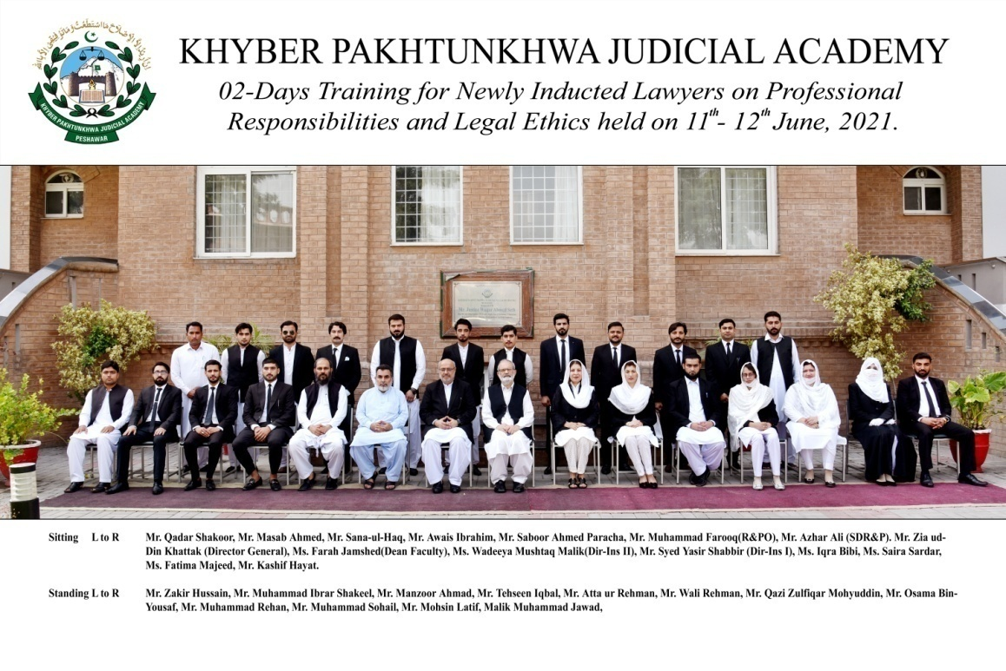
Prepared by:
Wadeeya Mushtaq Malik (Director Instruction-II)
Finalized by:
Ms.Farah Jamshed (Dean Faculty)
______________________________________________________________________________Khyber Pakhtunkhwa Judicial Academy, Old Sessions Court Building, Jail Road, Peshawar
info@kpja.edu.pk | www.kpja.edu.pk

1.0 Introduction

1.1 KPJA is statutorily mandated to provide training to all justice sector stakeholders, to hold conferences, seminars, lectures, workshops and symposia in matters relating to court management, administration of justice, law and development of skills in legislative drafting and to establish liaison with research institutions, universities and other bodies including the Federal Judicial Academy, towards the cause of administration of justice. (Section 4 of the Academy Act)
1.2 Capacity building in every field of judicial activity is a sine qua non for streamlining the system in its entirety. With this end in view, KPJA arranged two-day training for newly inducted lawyers across KP Province.

2.0 Purpose of the report

2.1 This report aims to assess the quality and impact of the training delivered from 11th to 12th June 2021.
2.2 The report begins with a general layout of the training session including, information about the participants, the resource person details, schedule of activities, proceedings, followed by recommendations for future improvements.

3.0 Participants

3.1 Participants of the training were the newly inducted lawyers of District Haripur, Kohat, and Mardan. Table below, describes in detail, the names of participants.
S. No | Name | District
1 | Ms. Saira Sardar, Advocate | Haripur
2 | Ms. Iqra Bibi, Advocate | Haripur
3 | Mr. Tehseen Iqbal, Advocate | Haripur
4 | Mr. Sana-ul-Haq, Advocate | Haripur
5 | Mr. Mohsin Latif, Advocate | Haripur
6 | Mr. Awais Ibrahim, Advocate | Haripur
7 | Ms. Fatima Majeed, Advocate | Kohat
8 | Qazi Zulfiqar Mohyuddin, Advocate | Kohat
9 | Mr. Masab Ahmed, Advocate | Kohat
10 | Mr. Wali Rehman, Advocate | Kohat
11 | Mr. Kashif Hayat, Advocate | Kohat
12 | Malik Muhammad Jawad, Advocate | Kohat
13 | Mr. Saboor Ahmed Paracha, Advocate | Kohat
14 | Mr. Muhammad Sohail, Advocate | Mardan
15 | Mr. Osama Bin Yousaf, Advocate | Mardan
16 | Mr. Zakir Hussain, Advocate | Mardan
17 | Mr. Muhammad Rehan, Advocate | Mardan
18 | Mr. Atta ur Rehman, Advocate | Mardan
19 | Mr. Qadar Shakoor, Advocate | Mardan
20 | Mr. Muhammad Ibrar Shakeel, Advocate | Mardan
21 | Mr. Manzoor Ahmad, Advocate | Mardan

4.0 Resource Persons

4.1 Ms. Farah Jamshed, Dean Faculty, Mr. Azhar Ali, Station Director/Senior Director Research & Publications, Mr. Syed Yasir Shabbir, Director Instruction-I, Ms. Wadeeya Mushtaq Malik, Director Instruction-II, Mr. Muhammad Farooq Research Officer, KPJA and Mr. Muhammad Ali adv. gave their insight on different subjects.
4.2 Schedule of Activities is detailed as:-

Day – 1: Friday -11-06-2021
S.# | Activities |  | Resource Person | Duration
1.1 | Professional Conduct  - Duty to Court  - Conduct with regard to Client  - Conduct with regard to other Advocates  - Conduct with regard to Public Generally |  | Ms. Farah Jamshed, Dean Faculty, KPJA | 09:00-10:30
1.2 | Administration of Justice  - Criminal Trial with focus on mental illness including forensic health assessment. |  | Mr. Azhar Ali, Senior Director Research & Publications, KPJA | 11:00-12:30
Day – 2 : Saturday -12-06-2021
2.1 |  | Production and Effect of Evidence  - Burden of Proof  - Examination of Witnesses | Ms. Wadeeya Mushatq Malik, Director Instructions-II, KPJA | 09:00 -10:30
2.2 |  | Professional Skills:  - Legal Drafting | Mr. Muhammad Ali, Advocate | 11:00-12:30
2.3 |  | Administration of Justice  - Civil Trial / Civil Case Management | Syed Yasir Shabbir,  Director Instructions-I, KPJA / Muhammad Farooq Research Officer, KPJA | 01:30-04:00

5.0 Proceedings
5.1 Ms. Farah Jamshed, Dean Faculty, delivered lecture on Professional Ethics & Conduct of Advocate with brief historical perspective in light of Legal Practitioner’s Bar Council Act 1965 and Legal Practitioners and Bar Council Act, 1973. Responsibilities of an advocate, in multifaceted legal arena in light of Chapter XII of LP&BC Rules were also highlighted.
5.2 The session summed up by emphasizing the multifaceted role of advocate and their prime responsibility to uphold the Rule of Law.
5.3 Mr. Azhar Ali, Station Director/Senior Director Research & Publication, delivered lecture on the Criminal Trial with special focus on mental illness including Forensic Health Assessment. His discourse centered on:
- The scheme of CrPC: preventive jurisdiction, investigation, inquiry, trial and special proceedings;
- The basis of adversarial proceedings;
- The element of the offense;
- Definition of insanity and insanity as defense;
- Mc Naughton Rule 1843;
- Durham Rule 1953;
- American Law institute Model penal Code;
- Concept of Insanity in Islam;
- Law of Lunatics(sections 464-475 CrPC);
- Prison Rules Chapter 18; and
- High Court Rules and Orders-Chapter 17 Volume III.
5.4 Mr. Syed Yasir Shabbir, delivered lecture on Administration of Justice with focus, on Civil Case Management Rules. He gave brief overview of amendments in the Code of Civil Procedure, 1908 since, year 2018 till date. He explained insertion of Order IX-A through an amendment by Peshawar High Court on 23-01-2018 in form of Case Management and Scheduling Conference to address the issue of delay in adjudication.
5.4 Ms. Wadeeya Mushtaq Malik, Director Instruction-II, delivered lecture on the Production and Effect of Evidence. The speaker explained burden of proof in the light of Article 119-128 of Qanoon-e-Shahadat Order, 1984, Presumptions of Fact under Article 96-98 , Art.129 and Legal Presumptions under Article 90-95 of Qanoon-e-Shahadat Order, 1984. Manner of examination of witnesses under Article 130-161 of Ibid Order was also explained.
5.5 Mr. Muhammad Farooq, delivered lecture on the scheme of the Code of Civil Procedure, 1908 regarding the jurisdiction of civil courts.
5.6 Mr. Muhammad Ali advocate delivered lecture on Legal Drafting. He emphasized the importance of soft skills, peer support, proper client interview, the study of statutes, and the case law. According to him, pleadings should follow a chronological order of introduction of parties, the relationship between the parties, followed by the controversy. The speaker was emphatic that language skills contributed a lot to good drafting.

6.0 Impact of the training

6.1 Significant indicators of the training impact are:
6.1.1 Whether the training contributed to an increase in the knowledge of the participants?
6.1.2 Whether that will translate itself into a practical utility?
The evaluation questionnaire was designed to deal with this aspect. The relevant feedback obtained from the participants is reflected below:

7.0 Quality of the training

7.1 As regards the quality of the training, it can be easily gleaned from the resource person’s evaluation by the participants. Moreover, the participants were asked to comment on the overall quality of the training program. Their response and the feedback, both on the assessment of the resource persons and the overall quality of the training program are shown in graphic form below:

7.2 Participants also furnished their general comments on the training. The same are reproduced verbatim:
- Training is gone well but the days are not as much as we can get a lot educated. Training must be 7 days where the lecture divided equally, as matter of time we skip a lot..totally on particular subject which got us a lot burden a lot the 7 days is a lot enough.
- It was nice time here, we learnt a lot in 2 days but 2 days more to be added in this workshop.
- We learnt to some extent in 2 days, but this training must be of 7 days to understand more.
- The overall training is too good and we learnt a lot and these training should be held on regular basis and for and should include more topics n time
- The overall training is too good and we learnt a lot and this is a very great initiative which improves the skills of the young lawyers and we are expecting that KP judicial academy will continue such efforts to engage the young lawyers and to break the ice between judges and lawyers.
- Overall training sessions were perfect. Time of session be extended.
- Overall it was the best n excellent.
- Every thing was too good and staff too cooperative.
- When recourse lecture is delivered then give hard copy after lecture. Residence must be near to academy. Must extend it for 5 days and give opportunity to all candidates of express view.
- The course was very helpful but was too short.
- 1. Incorporate other difficult topics 2. Should be distinct further 3. Provide federal level training 4. Involve other Districts as well.

8.0 Conclusion

8.1 Participants' graphic feedback indicates that the training's performance and effect have been rated very good.
8.2 Based on the participants' feedback, training modules can be further improved.
8.3 The trainees review reflect the achievement of training objectives.

