REPORT
Two-Day Training on Professional Responsibilities and Legal Ethics for Newly Inducted Lawyers of District Swabi
10-11 March 2021

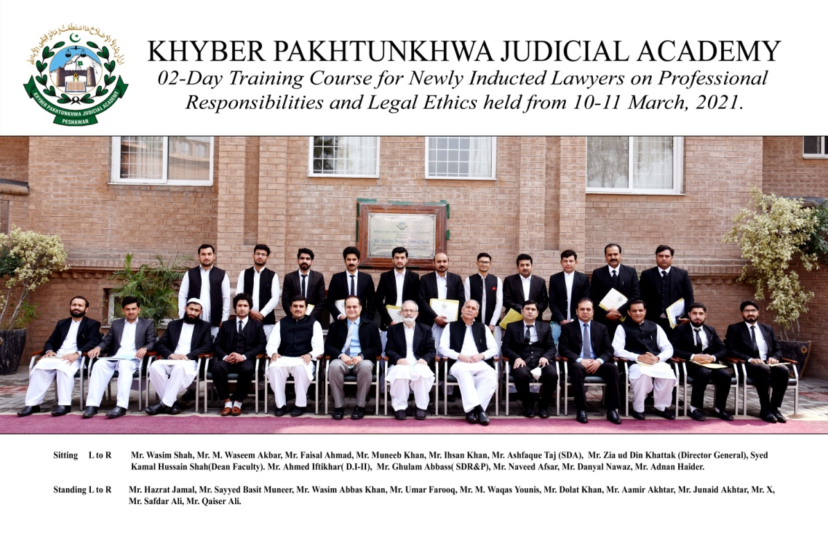
Prepared by:
Ahmed Iftikhar (Director Instructions)
Finalized by:
Syed kamal Hussain Shah (Dean Faculty)
______________________________________________________________________________Khyber Pakhtunkhwa Judicial Academy, Old Sessions Court Building, Jail Road, Peshawar
info@kpja.edu.pk | www.kpja.edu.pk

1.0 Introduction

1.1 KPJA is statutorily mandated to provide training to all justice sector stakeholders, to hold conferences, seminars, lectures, workshops and symposia in matters relating to court management, administration of justice, law and development of skills in legislative drafting and to establish liaison with research institutions, universities and other bodies including the Federal Judicial Academy, towards the cause of administration of justice. (Section 4 of the Academy Act)
1.2 Capacity building in every field of judicial activity is a sine qua non for streamlining the system in its entirety. With this end in view, KPJA arranged two-day training for newly inducted lawyers across KP Province.

2.0 Purpose of the report

2.1 This report aims to assess the quality and impact of the training delivered from 10th to 11th March 2021.
2.2 The report begins with a general layout of the training session including, information about the participants, the resource person details, schedule of activities, proceedings, followed by recommendations for future improvements.

3.0 Participants

3.1 Participants of the training were the newly inducted lawyers of District Swabi. Table below, describes in detail, the names of participants.

S.# | Name
1 | Mr. Qaiser Ali, Advocate
2 | Mr. Dolat Khan, Advocate
3 | Mr. Danyal Nawaz, Advocate
4 | Mr. Umar Farooq, Advocate
5 | Mr. Wasim Abbas Khan, Advocate
6 | Mr. Safdar Ali, Advocate
7 | Mr. Muneeb Khan, Advocate
8 | Mr. Faisal Ahmad, Advocate
9 | Mr. Muhammad Waseem Akbar, Advocate
10 | Mr. Junaid Akhtar, Advocate
11 | Mr. Aamir Akhtar, Advocate
12 | Mr. Wasim Shah, Advocate
13 | Sayyed Basit Muneer, Advocate
14 | Mr. Adnan Haider, Advocate
15 | Hazrat Jamal, Advocate
16 | Mr. Ihsan Khan, Advocate
17 | Mr. Naveed Afsar, Advocate
18 | Mr. Muhammad Waqas Younis, Advocate

4.0 Resource Persons

4.1 Syed Kamal Hussain Shah, Dean Faculty, Mr. Ashfaque Taj, Senior Director Administration, Mr. Ghulam Abas, Senior Director Research & Publications, and Mr. Ahmed Iftikhar, Director Instruction, KPJA, gave their insight on different subjects.
4.2 It would be necessary to make mention of each resource person along with topic dilated upon by him. The following table contains these details:-
SCHEDULE OF ACTIVITIES
Day – 1: Wednesday -10-03-2021
S.# | Activities | Resource Person | Duration
1.3 | Professional Conduct  - Duty to Court  - Conduct with regard to Client  - Conduct with regard to other Advocates  - Conduct with regard to Public Generally | Mr. Ghulam Abbas, Senior Director Research & Publications, KPJA | 09:00-10:30
1.4 | Administration of Justice  - Criminal Trial | Mr. Ashfaque Taj,  Senior Director Administration, KPJA | 11:00-12:30
2.2 | Administration of Justice  - Civil Trial | Syed Kamal Hussain Shah, Dean Faculty, KPJA | 01:30-03:00
Day – 2 : Thursday-11-03-2021
2.3 | Production and Effect of Evidence  - Burden of Proof  - Examination of Witnesses | Mr. Ahmed Iftikhar, Director Instructions, KPJA | 09:00-10:30
2.4 | Professional Skills:  - Legal Drafting | Mr. Muhammad Ali, Advocate | 11:00-12:30

5.0 Proceedings
5.1 Mr. Ghulam Abbas, Senior Director Research & Publication, delivered the lecture on Professional Ethics & Conduct of Advocate. He discussed definitions of morality, ethics, law, and legal ethics and explained them in the light of the Legal Practitioners &Bar Councils Act, 1973, and Chapter XII of the LP& BC Rules.
5.2 The speaker went into the details of advocate duties to the Court (Rules 159-167), advocate duties to the client (Rules 145-149), advocate duties towards other lawyers (Rules 134-144), and advocate conduct towards the general public (Rules 168-175-B). He also referred to important decisions of superior courts on the duties of the lawyer, including 2001 CLC 1559 Kar, 2018 PCrLJ 34, 2008 YLR 812, 2001 MLD 157, 2016 SCMR 141, PLD 2006 SC AJK 69, 2002 CLC Disciplinary Tribunal KPBC, 2016 PTD 2043, 1993 SCMR 2132, 2000 YLR 1102, 2015 SCMR 882 and 1999 CLC 1901.
5.3 The resource person said that lawyers should be mindful of the consequences of the breach of ethical obligations under the law, in the eyes of the public and the legal fraternity.
5.4 The speaker recommended the following books for a good grasp of the advocate role and duties;
- Be A Competent Lawyer, S.M. Zafar
- The End of Lawyers? Rethinking the Nature of Legal Services” Richard Susskind
- Alternative Perspectives on Lawyers and Legal Ethics: Reimagining the Profession. Reid Mortensen, (Routledge)
- Legal Ethics, William P. Alford,
- Raising the Bar: The Emerging Legal Profession in East Asia and others.” Henry L. Stimson, Harvard Law School.
- Making Your Case: the Art of persuading Judges. “ Bryan Garner & Antonin
5.5 Mr. Ashfaque Taj, Senior Director Administration, delivered delivered the lecture on the CRIMINAL TRIAL WITH FOCUS ON MENTAL ILLNESS INCLUDING FORENSIC HEALTH ASSESSMENT. His discourse centered on:
- The scheme of CrPC: preventive jurisdiction, investigation, inquiry, trial and special proceedings;
- The basis of adversarial proceedings;
- The element of the offense;
- Definition of insanity and insanity defense;
- Mc Naughton Rule 1843;
- Durham Rule 1953;
- American Law institute Model penal Code;
- Concept of Insanity in Islam;
- Law of Lunatics(sections 464-475 CrPC);
- Prison Rules Chapter 18; and
- High Court Rule and Orders-Chapter 17 Volume III.
5.6 Syed Kamal Hussain Shah, Dean Faculty, delivered the lecture on Administration of Justice: Civil Trial. He in the beginning informed the participants about the evolution of laws from the pre-partition days, the Indian Act of 1850, the N.W.F.P Regulation of 1901, and the three different statutes of Civil Procedure passed in 1859, 1872, and 1908 respectively. He then explained different stages of the Civil Trial and explained the importance of verification of pleadings on oath, Order V Rule 5 in proper service of summon, the determination of court fee, the material from which issues are to be framed, the kinds of issues, the proper fixation of onus and the role of witnesses of record. The speaker also highlighted the significance of the precedents.
5.7 Mr. Ahmed Iftikhar, Director Instruction-II, delivered the lecture on the Production and Effect of Evidence. The speaker explained:
- The difference between relevancy as a matter of logic and admissibility as a matter of policy;
- The principles of policy to exclude evidence based on admissibility;
- The applicability of principles of admissibility in indirect, circumstantial, and real evidence;
- Difference between relevancy, admissibility, weight, and proof;
- Principles of the weighing of the evidence;
- The general principle of he who asserts the affirmative must prove;
- The failure test;
- The presumptions and shifting of onus; and
- Comparative perspective of Islamic and English Law of Evidence
5.8 Mr. Muhammad Ali advocate delivered the lecture on Legal Drafting. He emphasized the importance of soft skills, peer support, proper client interview, the study of statutes, and the case law. According to him, pleadings should follow a chronological order of introduction of parties, the relationship between the parties, followed by the controversy. The speaker was emphatic that language skills contributed a lot to good drafting.

6.0 Impact of the training

6.1 Significant indicators of the training impact are:
6.1.1 Whether the training contributed to an increase in the knowledge of the participants?
6.1.2 Whether that will translate itself into a practical utility?
The evaluation questionnaire was designed to deal with this aspect. And the relevant feedback obtained from the participants is reflected below:

7.0 Quality of the training

7.1 As regards the quality of the training, it can be easily gleaned from the resource person’s evaluation by the participants. Moreover, the participants were asked to comment on the overall quality of the training program. Their response and the feedback, both on the assessment of the resource persons and the overall quality of the training program are shown in graphic form below:

7.2 Participants also furnished their general comments on the training. The same are reproduced verbatim:
- Training should be at least one week session
- Please extend duration of the training
- Time duration of training session was too short

8.0 Conclusion

8.1 Participants' graphic feedback indicates that the training's performance and effect have been rated very good.
8.2 Based on the participants' feedback, training modules can be further improved.
8.3 According to trainees' reviews, it was the achievement of the objectives for which the training was designed and conducted.

