REPORT
Five-Day Pre-Service Training for Assistant Public Prosecutors
26-30 July 2021
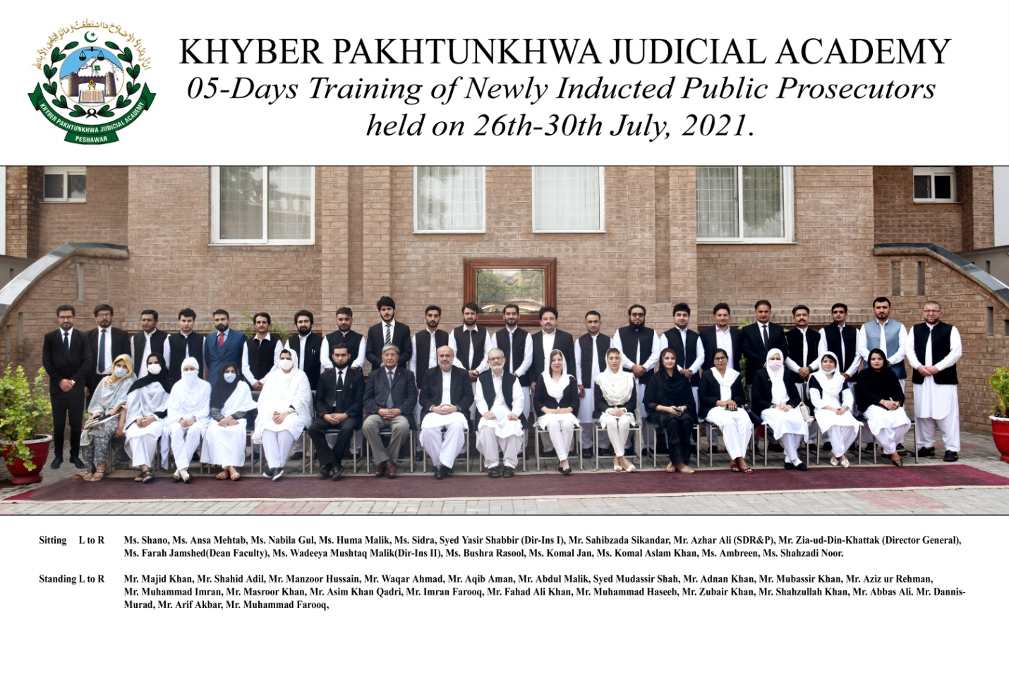
Prepared by:
Syed Yasir Shabbir (Director Instruction-I)
Finalized by:
Ms.Farah Jamshed (Dean Faculty)
______________________________________________________________________________Khyber Pakhtunkhwa Judicial Academy, Old Sessions Court Building, Jail Road, Peshawar
info@kpja.edu.pk | www.kpja.edu.pk

1.0 Introduction

1.1 KPJA is statutorily mandated to provide training to all justice sector stakeholders, to hold conferences, seminars, lectures, workshops and symposia in matters relating to court management, administration of justice, law and development of skills in legislative drafting and to establish liaison with research institutions, universities and other bodies including the Federal Judicial Academy, towards the cause of administration of justice. (Section 4 of the Academy Act)
1.2 Capacity building in every field of judicial activity is a sine qua non for streamlining the system in its entirety. With this end in view, KPJA arranged five-day training for newly inducted Assistant Public Prosecutors across KP Province.

2.0 Purpose of the report

2.1 This report aims to assess the quality and impact of the training delivered from 26th to 30th July 2021.
2.2 The report begins with a general layout of the training session including, information about the participants, schedule of activities, and proceedings, followed by recommendations for future improvements.

3.0 Participants

3.1 Participants of the training were the newly inducted Assistant Public Prosecutors across KP Province. Table below, describes in detail, the names of participants.
S# | Name | Designation
 | Ms. Sidra | Assistant Public Prosecutor
 | Ms. Shano | Assistant Public Prosecutor
 | Mrs. Ansa Mehtab | Assistant Public Prosecutor
 | Ms. Bushra Rasool | Assistant Public Prosecutor
 | Ms. Ambreen | Assistant Public Prosecutor
 | Ms. Komal Jan | Assistant Public Prosecutor
 | Ms. Nabila Gul | Assistant Public Prosecutor
 | Ms. Huma Malik | Assistant Public Prosecutor
 | Ms. Komal Aslam Khan | Assistant Public Prosecutor
 | Ms. Shehzadi Noor | Assistant Public Prosecutor
 | Mr. Muhammad Farooq | Assistant Public Prosecutor
 | Mr. Shahid Adil | Assistant Public Prosecutor
 | Mr. Manzoor Hussain | Assistant Public Prosecutor
 | Mr. Masroor Khan | Assistant Public Prosecutor
 | Mr. Dannis Murad | Assistant Public Prosecutor
 | Mr. Abbas Ali | Assistant Public Prosecutor
 | Mr. Muhammad Haseeb | Assistant Public Prosecutor
 | Mr. Abdul Malik | Assistant Public Prosecutor
 | Mr. Aziz ur Rehman | Assistant Public Prosecutor
 | Mr. Mubassir Khan | Assistant Public Prosecutor
 | Mr. Waqar Ahmad | Assistant Public Prosecutor
 | Mr. Imran Farooq | Assistant Public Prosecutor
 | Mr. Shahzullah Khan | Assistant Public Prosecutor
 | Mr. Adnan Khan | Assistant Public Prosecutor
 | Mr. Muhammad Imran | Assistant Public Prosecutor
 | Mr. Fahad Ali Khan | Assistant Public Prosecutor
 | Mr. Asim Khan | Assistant Public Prosecutor
 | Mr. Aqib Aman | Assistant Public Prosecutor
 | Mr. Zubair Khan | Assistant Public Prosecutor
 | Syed Mudassir Shah | Assistant Public Prosecutor
 | Mr. Arif Akbar | Assistant Public Prosecutor
 | Mr. Majid Khan | Assistant Public Prosecutor

4.0 Schedule of Activities

4.1 Schedule of Activities is detailed as:-
Day – 1: Monday -26-07-2021
S.# | Activities |  |  | Resource Person | Duration
 | Registration & Pre-Evaluation  Recitation from the Holy Quran |  |  |  | 08:30 – 8:45
 | Welcome Address / Orientation |  |  | Director General | 08:45 – 9:00
1.1 | Role of Prosecutors & Importance of Prosecution  - Professional conduct, ethics & mannerism  - Conduct with regard to Public Generally |  |  | Sahibzada Sikandar, District Public Prosecutor (Rtd) | 09:00-10:30
 | Tea Break (10:30-11:00)
1.2 | Scrutiny of Brief at pre-trial stage  - Guidelines for scrutiny of cases  - Insertion/deletion of sections of law in cases  - Safeguard of public interest |  |  | Sahibzada Sikandar, District Public Prosecutor (Rtd) | 11:00-12:45
Lunch Break 12:45 – 1:30
1.3 | Administration of Justice  - Criminal Trial with focus on mental illness including forensic health assessment |  |  | Mr. Azhar Ali, Senior Director Research & Publications, KPJA | 1:30 – 2:30
Day – 2 : Tuesday - 27-07-2021
 | Recitation from the Holy Quran |  |  |  | 8:55-9:00
2.1 |  | Opinion writing (Pre registration of case)  - Supervision of process of investigation  - Withholding of prosecution  - Challan and Final report |  | Mr. Ateeq-ur-Rehman, Director Admn Directorate of Prosecution | 09:00 -10:30
Tea Break (10:30 – 11:00)
2.2 |  | Practical Exercise  Mock pre-trial  - Forwarding of :-  - Application for police custody  - Application for confessional statement  - Warrants under u/s 204 Cr.PC  - Proclamation u/s 87Cr.P.C  - Transit custody  - Transfer of Accused |  | Faculty Members | 11:00-12:45
Lunch Break 12:45 – 1:30
2.3 |  | Prosecution under special laws  - JJSA,2018  - CPA,2010 |  | Mr. Sangeen Shah, Senior Public Prosecutor | 1:30 – 2:30
Day – 3 : Wednesday - 28-07-2021
 | Recitation from the Holy Quran |  |  |  | 8:55-9:00
3.1 |  | Effective Prosecution of cases  - Police- Prosecution coordination  - Scrutiny of Calendar of witnesses  - Briefing of Official witnesses with special focus on IOs.  - Examination of witnesses including Defense and hostile witnesses |  | Mr. Ateeq ur Rehman, Director Admn Directorate of Prosecution | 09:00 -10:30
Tea Break (10:30 – 11:00)
3.2 |  | Practical Exercise Session -I  - Mock Trial  - Scrutiny of Formal Charge  - Examination of witnesses including Defence and hostile witnesses  - Exhibition of Documentary evidence  - Criminal Appeals , Criminal Revisions & Miscellaneous applications |  | Faculty Members | 11:00-12:45
Lunch Break 12:45 – 1:30
3.3 |  |  | Practical Exercise Session -II  Continued …..  Visit to Forensic Sciences Laboratory(FSL)subject to availability of time | Faculty Members | 1:30-2:30
Day4: Thursday 29-07-2021
4.1 |  |  | Case property  - Production & exhibition of case property.  - Ensuring safe custody &safe transit of case property  - Ensuring availability of expert opinions /reports | Malik Amjid Inayat, Senior  Advocate | 09:00-10:30
 |  |  | Tea Break 10:30-11:00
4.2 |  |  | Bail (Concept, logic & procedure)  - Bail in Bailable cases(496)  - Non-bailable cases(497)  - Anticipatory/transit/Bail before arrest.(498)  - Bail cancellation[497(5)] Cr.PC | Mr. Jalal-ud-Din Akbar Azam Ghara, Senior Advocate | 11:00-12:45
 |  |  | Lunch Break 12:45 – 1:30
4.3 |  |  | Practical Exercise  - Full arguments on trial  - Criminal Appeal, Revision and Misc. Applications | Faculty Members | 1:30 -2:30
Day5: Friday 30 -07-2021
5.1 |  |  | Justice of Peace u/s 22-A Cr.P.C  with focus on the latest law on the subject.  - Cross versions  - Change of investigation | Mr. Aamir Javed,  Senior Advocate | 9:00-10:30
5.2 |  |  | Tea Break 10:30 to 11:00
5.3 |  |  | Personal Opinion (One pager) / Feedback Session | Faculty Members | 11:00-12:00
5.4 |  |  | Concluding Ceremony  - Class Representative Remarks  - Concluding address of the Director General |  | 12:00  Onwards

5.0 Proceedings

5.1 Day 1
5.1.1 The Director General, KPJA, Mr. Zia-ud-Din Khattak chaired the orientation session. In his welcome address highlighted the pivotal role of Public Prosecutors in the criminal justice sector by briefly recollecting the relevant laws, rules and regulations on the subject.
5.1.2 Sahibzada Sikandar, District Public Prosecutor (Rtd), gave two exhaustive lectures on the Role of Prosecutors & Importance of Prosecution and the Scrutiny of Brief at pre-trial stage. His focus was on professionalism, ethics and mannerism in dealing with the general public. He also sensitized the trainees about the guidelines for scrutiny of cases at pre-trial stage with reference to insertion/deletion of sections of law and about the safeguarding of public interest.
5.1.3 Mr. Azhar Ali, Station Director/Senior Director Research & Publication, delivered lecture on the Criminal Trial with special focus on mental illness including Forensic Health Assessment.

5.2 Day 2
5.2.1 Mr. Ateeq-ur-Rehman, Director Admin, Prosecution Department KPK, delivered lecture on Opinion Writing at Pre-Registration stage of a criminal case, supervision of process of investigation and opinion writing at the time of filing of challan and final report.
5.2.2 Lecture was followed by pre-trial mock activity. Trainees were divided into 4 groups and assigned task of forwarding of misc applications including all pre-trial stages of criminal case.
5.2.3 The mock trial was followed by second lecture by Mr. Ateeq ur Rehman on effective prosecution of cases. Areas highlighted by resource person were police-prosecution coordination, scrutiny of calendar of witnesses, briefing of official witnesses with special focus on IOs & examination of witnesses including defense and hostile witnesses.

5.3 Day 3
5.3.1 Mr. Sangeen Shah, Senior Public Prosecutor, Malakand, delivered a comprehensive lecture on prosecution of cases under special laws with focus on the Juvenile Justice System Act, 2018 and Child Protection and Welfare Act, 2010.
5.3.2 Lecture was followed by visit of the trainee Prosecutors to the Forensic Sciences Laboratory, Peshawar where they were briefed about the administrative set-up and FSL and were shown the various sections and labs including the chemical examination lab, the handwriting and fingerprints section and the ballistics and firearms section. The experts demonstrated a few techniques and protocols used for physical and chemical analysis of various samples.
5.3.3 The last activity of the day was a mock trial covering the stages of a criminal trial. Trainees were divided into 4 groups and assigned the tasks of scrutiny of formal charge, exhibition of documentary evidence, examination of witnesses including defense and hostile witnesses.

5.4 Day 4
5.4.1 Mr. Malik Amjad Inayat Advocate delivered an exhaustive discourse on Production & Exhibition of Case Property, ensuring safe custody and safe transit of case property and ensuring the availability of expert opinions and reports on the case files of criminal trials.
5.4.2 Mr. Jalal-ud -Din Akbar Azam Khan Ghara Advocate, delivered a detailed lecture on the concept, logic and procedure for grant and refusal of bails in bailable and non-bailable cases. He also apprised the trainees about the procedure and requirements of anticipatory, transit and ad-interim pre-arrest bails.
5.4.3 The last activity of the day was again a mock trial covering the final stages of a criminal trial. Trainees were divided into 4 groups and assigned the tasks of examination of witnesses including defense and hostile witnesses, examination of accused u/s 342 CrPC, statement of accused on oath u/s 340(2) CrPC, advancing final arguments, filing of criminal misc applications, appeals and revisions.

5.5 Day 5
5.5.1 On the last day of training Mr. Aamir Javed, Advocate Supreme Court, delivered a comprehensive lecture on Justice of Peace (powers, functions and responsibilities u/s 22-A Cr.P.C). He sensitized the trainees about cross versions and procedure for change of investigation with focus on the latest case law.
5.5.2 Trainees were tasked to write Personal Opinion Paper in respect of their views/thoughts before and after training, Practical aspect of the training, and their Take Home Segment of the entire training activity.
5.2.3 The training activity was concluded by the closing ceremony. Class Representative in his remarks thanked the Academy for arranging the subject training and appreciated the practical approach adopted in devising the training modules. The worthy Director General congratulated the trainees on the successful completion of the training and wished them best of luck for their future. The ceremony ended with distribution of certificates amongst the participants.

6.0 Impact of the training

6.1 Significant indicators of the training impact are:
6.1.1 Whether the training contributed to an increase in the knowledge of the participants?
6.1.2 Whether that will translate itself into a practical utility?
The evaluation questionnaire was designed to deal with this aspect. The relevant feedback obtained from the participants is reflected below:

7.0 Quality of the training

7.1 As regards the quality of the training, it can be easily gleaned from the resource person’s evaluation by the participants. Moreover, the participants were asked to comment on the overall quality of the training program. Their response and the feedback, both on the assessment of the resource persons and the overall quality of the training program are shown in graphic form below:

7.2 Participants also furnished their general comments on the training. The same are reproduced verbatim:
- The course was good don't change it but there is always room for improvement, so further addition of some other relevant topics and jail visits will be highly appreciated if agreed.
- It's all fine.
- Extend duration of time.
- The foremost suggestion would be that the time period for such heavy number of topics should be enhanced.
- Enlarging scope of course module.
- The duration for training of prosecution shall be enhanced, one or two working day visits to FSL and hospital for postmortem observation, more practical activities.
- A session should be only for any type of question in course work.
- Duration must be increased. Mistakes must be noted.
- The time should at least be of seven days for the training.
- The duration shall be increased.

8.0 Conclusion

8.1 Participants' graphic feedback indicates that the training's performance and effect have been rated good.
8.2 Based on the participants' feedback, training modules can be further improved.
8.3 The trainees review reflects the achievement of training objectives.

