REPORT
One Day Consultative Session on the Feasibility & Effectiveness of Special Courts for Juveniles
December 19, 2018
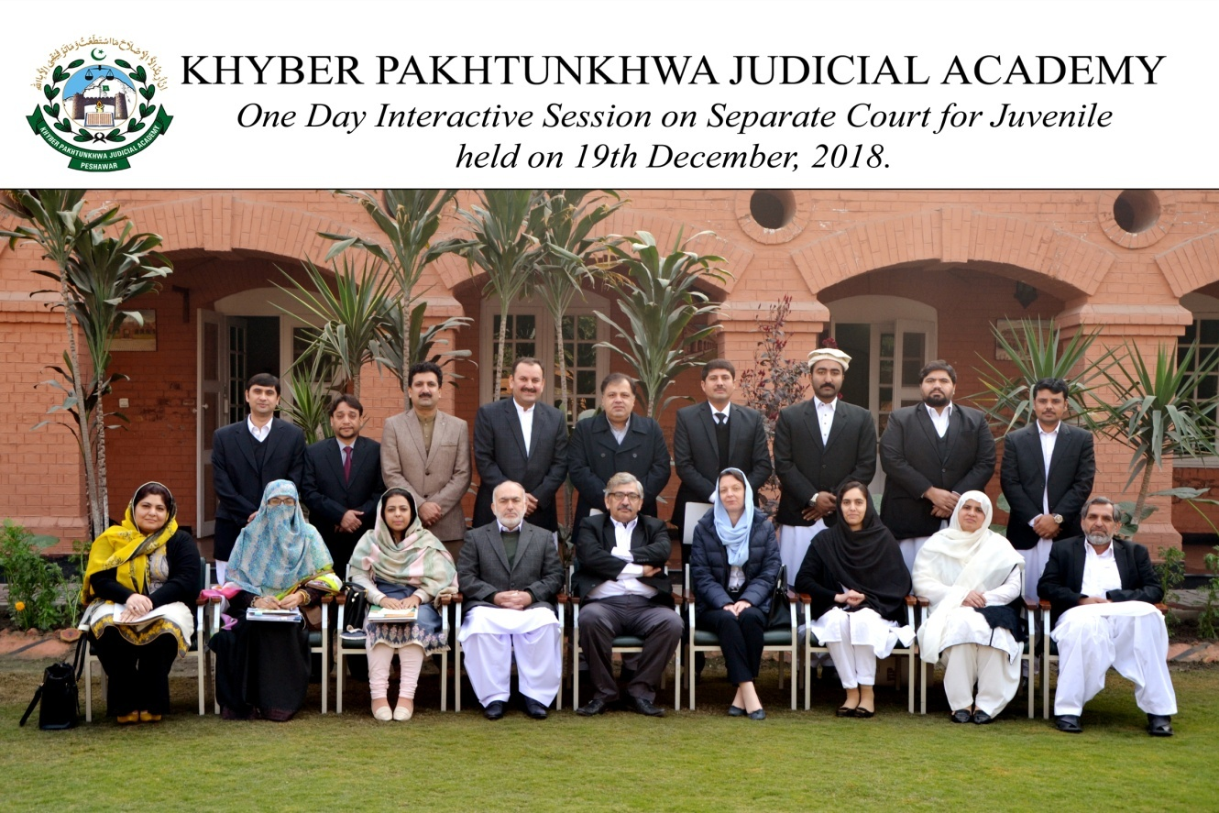
Prepared by:
Dr. Shakeel Azam Awan (Dean Faculty)
Ahmed Iftikhar (Director Instruction)
______________________________________________________________________________Khyber Pakhtunkhwa Judicial Academy, Old Sessions Court Building, Jail Road, Peshawar
info@kpja.edu.pk | www.kpja.edu.pk

1.0 Introduction

1.1 KPJA is statutorily mandated to provide training to all justice sector stakeholders, to hold conferences, seminars, lectures, workshops and symposia in matters relating to court management, administration of justice, law and development of skills in legislative drafting and to establish liaison with research institutions, universities and other bodies including the Federal Judicial Academy, towards the cause of administration of justice. (Section 4 of the Academy Act)
1.2 The Juvenile Justice System Ordinance was promulgated in the year 2000 with the avowed aim to safeguard the rights of children as accused. The legislation failed to achieve the desired objective. The new law, Juvenile System Act, was passed in the year 2018. It promises a paradigm shift: the disposal of cases through diversion; Juvenile Justice Committees; Observation Homes; Juvenile Rehabilitation Centers; and separate trial of juveniles. However, the begging question is whether existing courts flooded with litigation of diverse nature can keep a promise of the new legislation?
1.3 Ms. Valerie khan Yousafzai, Executive Director of Group Development Pakistan, in a meeting organized in Peshawar High Court, raised her concern for the establishment of separate courts under the Juvenile Justice System Act in KP Province. In this backdrop and in compliance with the directions of Worthy Registrar Peshawar High Court, KP Judicial Academy organized a one-day interactive session on the Feasibility and Effectiveness of Special Courts for Juveniles.

2.0 Purpose of the report

2.1 This report aims to assess the impact of the consultative session held on 19th December 2018.
2.2 The report begins with information about the participants, followed by a summary of the sessions.

3.0 Participants

3.1 Participants of the session were the stakeholders from diverse section of the society and the government departments. Table below, describes in detail, the names of participants.
S. No | Name | Designation | Department
1 | Ms. Qurat-ul-Ain Alam | Advocate (Nominee of the Bar Council)
2 | Mr. Mansoor Akhtar | Advocate (Nominee of the Bar Council) | Social Welfare Department
3 | Mr. Waheed Ullah | Assistant Director | Probation & Reclamation Department
4 | Mr. Muhammad Sufian Malik | Joint Secretary | Peshawar High Court Bar Association
5 | Ms. Amana Waheed | Director Program | KPCSW
6 | Ms. Tehreema Sabahat | Assistant Legal Draftsperson | Peshawar High Court
7 | Mr. Arif Khan | Deputy Director | Prison Department
8 | Mr. Waqas Azeem | Advocate (Nominee of the Bar Council)
9 | Mr. Aabid Sarwar | Director NJPIC | Peshawar High Court
10 | Ms. Irum Nosheen | Director Instructions-II | KP Judicial Academy
11 | Mr. Ahmed Iftikhar | Director Instructions-I | KP Judicial Academy
12 | Mr. Zia-ur-Rehman | Director Administration | KP Judicial Academy
13 | Mr. Ijaz Ali | Judiciary Focal Person | UNDP

Summary of Session 1
4.1 Director Instructions KPJA hosted the session. The session began with the recitation of the Holy Quran. In his introductory speech, DG KPJA welcomed the participants. He also gave the background and objectives of the consultative session in his speech.
  - Ms. Valerie khan Yousafzai, the Executive Director of Group Development Pakistan, delivered a presentation on; ”Protecting Children in Criminal Justice System”; and “Juvenile Courts in Pakistan: Feasibility and Effectiveness”.

  - In her first presentation Ms. Valerie khan explained;
- Essential cross-cutting principles of justice for children: the best interest; protection; right of hearing; and non-discrimination
- The child at Risk
- Age of criminal responsibility and age determination methods
- Rights of children on the arrest
- Concept of diversion
- Concepts woven with the child-friendly courts: Avoiding secondary victimization, relevant staff, steps to set up juvenile courts and monitoring their efficiency, relevant equipment, video recording system, games, play area, stationary, computers, screen, furniture, MIS.

  - In her second presentation Ms. Valerie Khan ,explained:
- Concepts aligned with UNCRC, ICCPR, CAT, Pakistan Constitution and JJSA 2018
- Essential prerequisites of the new regime: Juvenile Committees, Observation Room, Court Room/Playing Video Room/Prosecution Room/Video Linkage, Trained Judicial Team, Rules/SOPs, a psychologist trained on child clinical care.
4.5 Ms. Valerie khan referred to the working of special juvenile courts set up at Lahore.

5.0 Summary of Session 2
The second session was an open house discussion. Ahmed Iftikhar Director Instruction and Zia-Ur-Rehman Director Instruction moderated the session. Following are key highlights of the session:
Barrister Quratulain:
- Awareness-raising is important
- Court procedure should be friendly
- The Child should be encouraged to explain his/her views and feelings.
- There should be a psychologist as a child expert permanently seated in the court.
Abid Sarwar (Director NJPMC PHC):
- The domain of child court will not be restricted to offenses.
- Paramount consideration is the welfare of the child.
- Child protection officer plays a pivotal role.
Amana Waheed (KP Commission on Status of Women)
- Data gathering on the working of special court will be important.
Arif khan (Deputy Director Prison):
- We endorse the idea of special courts.
- There are 326 juvenile prisoners in KPK.
- Borstal institutions exist only in two districts. More such institutions are needed, though that is for Probation and Parole Department to see.
Mansoor Akhtar (Advocate)
- There is a need to work on factors that contribute to making juvenile criminals.
DG KPJA:
1. There is a dire need to frame rules under the Juvenile Justice System Act.
Ms. Valerie Khan:
- Of course, we are facing lots of challenges. And we need to do more work. Similarly, we do have in mind to take a holistic approach.
- Trained prosecutors, probation officers, social welfare officers and lawyers will be needed to set the regime right and ensure a fair trial.
Khawaja Wajihuddin (Registrar PHC):
1. We are not trying to replicate any model. We have to come up with a solution following our ground realities and that is our focus.

Conclusion
  - Participants had a consensus on creation of separate juvenile courts.
  - In a concluding address, Worth Registrar PHC observed, “Every single minute matters, every single child matters, every single childhood matters, and every major society is best judged by its capacity and commitment to take care of its vulnerable segments.”

