KPJA E-BULLETIN
APRIL 2016

Contents
First Ever Pre-Service Training For Newly Appointed AdJs Concluded 4
03-Day Training on Gender Mainstreaming and Women Empowerment (5-7 April, 2016) Concluded 6
5-day training on Substantive&Procedural Laws for Civil Judge cum Judicial Magistrates/Alaqa Qazis concluded 7
02-day Specialized Course on Intellectual Property Rights for Additional District & Sessions Judge/Izafi Zilla Qazis Concluded 8
UNDP and SDC visit 9
05 day training on 'Substantive & Procedural Laws' for newly promoted District & Sessions Judges/ Zila Qazis (2nd Week) concluded 10
Forthcoming Events 11

Events & Activities of April (2016) in Brief

First Ever Pre-Service Training For Newly Appointed AdJs Concluded
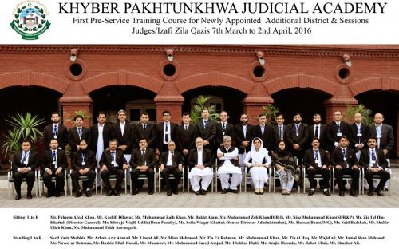
Since its inception in 2012, KP Judicial Academy has been engaged with the in-service training of judicial officers. The KP Judicial Academy recognizes the importance of both pre- and in-service training in the capacity building of the judicial officers. A milestone in the history of KP Judicial Academy was achieved when a one month long (7th March to 2nd April, 2016) pre-service training course for newly appointed probationers Additional District & Sessions Judges/ Izafi Zilla Qazis was planned, designed and put into practice. The training was designed keeping in view the job description of the probationers, practicalities involved in their functions and the likely impediments in the dispensation of justice. The focus areas also included the capacity building, professional competence, ethical standards with related skills and attitude. The specific training objectives were to deepen the trainees knowledge of jurisprudence and universal principles of natural justice, to help the trainees develop judicial temperament reflecting judicial ethical values, to enable the trainees apply substantive and procedural laws properly, to inculcate in the trainees judicial decision making and opinion writing skills and to impart to the trainees skills for efficient and effective communication. In accordance with these objectives the Academy followed a training methodology in four areas of delivery, participation, conduct and curriculum. Extension lectures were delivered by persons of high profiles. Research skills along with language and linguistics skills were also part of the training program. The modules were developed in accordance with the objectives defined and each module had learning objectives and outcomes. The participants also delivered their presentations which were assessed by a panel of evaluators. The probationers also visited Forensic Sciences Lab and Khyber Medical College as part of their curricular and co-curricular activities. The new developed software for evaluation was used for the first time. This software is developed by KPJA in coordination with UNDP by outsourcing to a consultant. The basic idea is of Kirk Patrick model of evaluation.
The concluding ceremony was simple but impressive. The class representative spoke on the occasion. Mr. Zia ud Din Khattak DG of Academy formally concluded the ceremony and conferred certificates on the participants. The probationers were bade farewell with the slogan "enter to learn and leave to serve".

03-Day Training on Gender Mainstreaming and Women Empowerment (5-7 April, 2016) Concluded

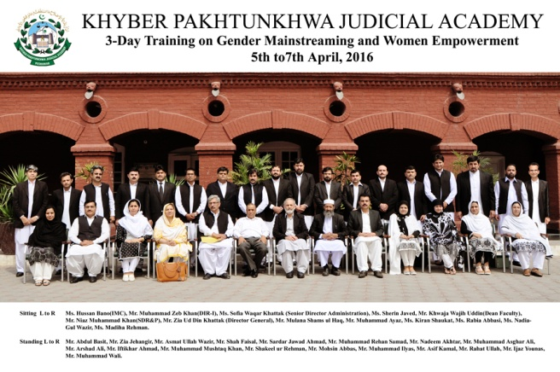
A 03 day training comprising a batch of 25 male and female Civil Judges/Judicial Magistrate on Gender Mainstreaming and Women Empowerment was conducted at the Academy. The training was organized in collaboration with the Aurat Foundation Pakistan, Peshawar office and UNDP. This was in continuation of training on women rights held last year. The topics of the sessions included Violence against women and legal protection, Judicial verdicts, International Instruments, National Legislation and Women rights to inheritance and its implementation. The training concluded on 7th April. On the occasion of the concluding ceremony, Mr. Zia ud Din Khattak awarded certificates to the participants.

5-day training on Substantive & Procedural Laws for Civil Judge cum Judicial Magistrates/Alaqa Qazis concluded

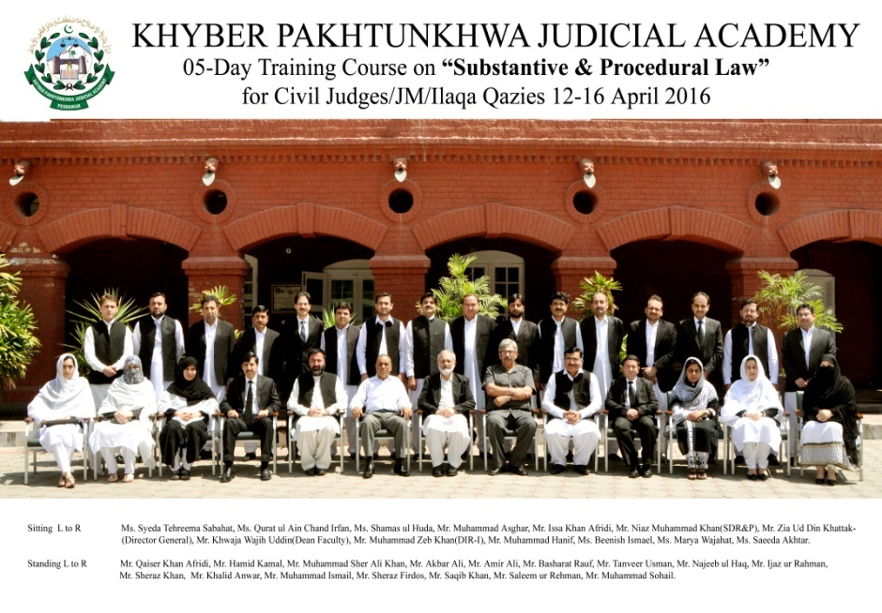
05-days training on Substantive & Procedural Laws for Civil Judges from 12 to 16 April 2016 was successfully concluded. Civil Judges cum Judicial Magistrates from various districts of Khyber Pakhtunkhwa participated in the training. The training was focused on Pre Trial (Criminal) Proceedings, Practical Exercise on Framing of Charge, Bail: Theory and Practice, Hurts under PPC: classification and punishments, Study of ADR in various Statutes, Initial adjudication of civil suits, Hudood Laws: Notable distinctions between Qisas, Hadd and Tazir, Land records: preparation and use in land disputes, Supervisory role of Magistrate under CrPC. Director General KPJA Mr. Zia ud Din Khattak distributed certificates amongst the participants of the course.

02-day Specialized Course on Intellectual Property Rights for Additional District & Sessions Judge/Izafi Zilla Qazis Concluded

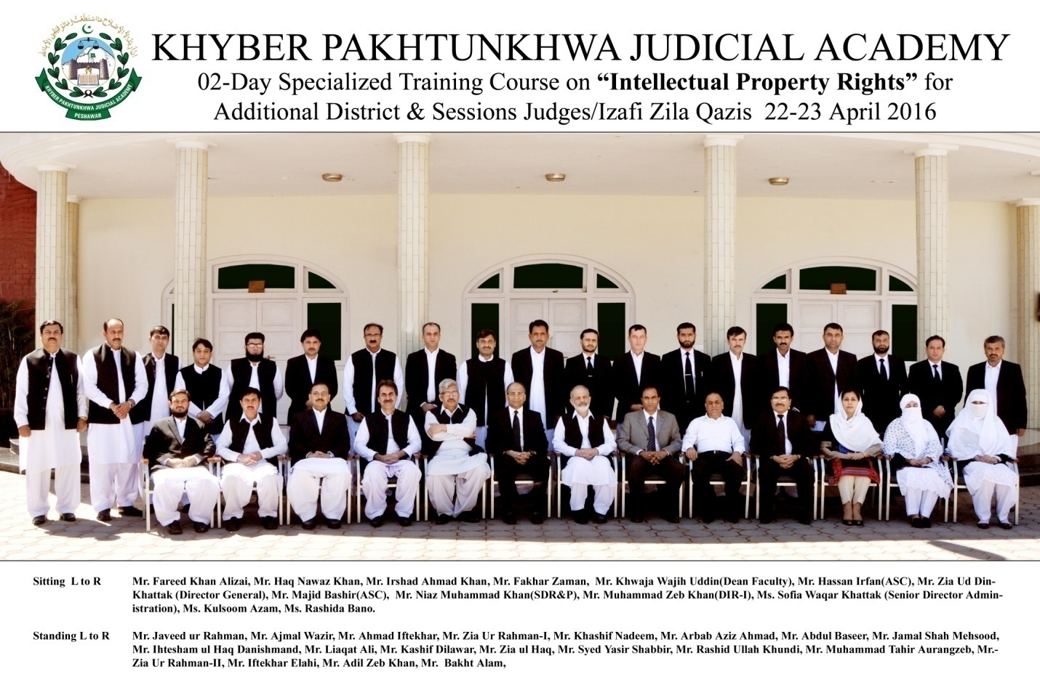
In addition to the conventional topics, the Academy draws on a diverse mandate for training in various laws and laws-related areas, such as, to name a few, anti-terrorism, forensic, banking, trade and commerce, intellectual property, anti-corruption, labour, cyber crimes, environment, human rights, particularly of women and children and the interface between law and development, law and society.
The need for sensitizing and apprising the judges of the district judiciary on the subject of intellectual property rights, the Judicial Academy arranged two day Specialized Course on Intellectual Property Rights for Additional District & Sessions Judge/Izafi Zilla Qazis. The specialized course was focused on Overview of Intellectual Property, Intellectual Property Laws in Pakistan, International Obligation and Commitments, IP Tribunals, Its Power, Jurisdiction and Appeal, Registration of IP Rights. A total of 25 Additional District and Sessions Judges from various districts of Khyber Pakhtunkhwa participated. On the occasion of the concluding ceremony, Mr. Zia ud Din Khattak awarded certificates to the participants.

UNDP and SDC visit
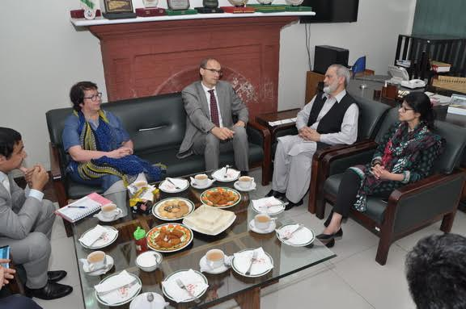
A delegation from the Swiss Development Corporation (SDC) along with UNDP visited the Academy on 28th April. The delegation visited various sections of the Academy including, the Research Wing, Library, Radio Meezan studios, Mediation Center. A briefing was also given to the team about the progress of KP Judicial Academy. The delegation appreciated the academic achievements and research studies conducted by the Academy and also expressed immense pleasure on the progress made by KPJA in very short span of time.

05 day training on 'Substantive & Procedural Laws' for newly promoted District & Sessions Judges/ Zila Qazis (2nd Week) concluded

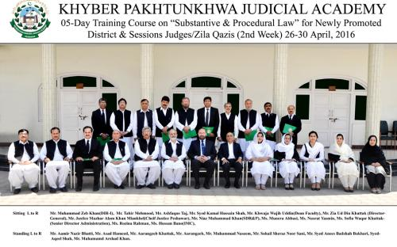
The first ever mandatory training of two weeks for probationers District and Sessions Judges was imparted by this academy. This was the second and final week of compulsory training. The training course on substantive & procedural law was designed so as to suit the requirements of particular strata of trainees. Recently a considerable number of judicial officers of K.P. District Judiciary were promoted as District & Sessions Judges. The promotion to the post of District & Sessions Judge/ Zilla Qazi is indeed paradigm shift in the role and responsibilities of the incumbent Judicial Officer. The post of District & Sessions Judge/ Zilla Qazi [D&SJ] outranks any other Officer in any other Department at the District Level. On the one hand he has to perform his judicial function by setting standards, which his team may follow and on the other hand, he has to coordinate with other stake holders of the Justice Sector at the District Level, so that the system of administration of justice may deliver the fruits to the downtrodden litigants. In these circumstances, it was the need of the hour that the Academy may rise up to the occasion by devising a training course, for the freshly promoted D&SJs so that they may efficiently and effectively perform leadership role at the District Level. The selection of resource persons were carried out meticulously. During formulation of the course, four broad areas requiring considerable emphasis of training were identified. They were the Ethics, Financial, Leadership role of District & Sessions Judge in administration of justice and human resource management. The training session based on the abovementioned thematic areas was conducted successfully.
At the end of the training, an impressive ceremony was held at the Khyber Pakhtunkhwa Judicial Academy, in which hon’ble the Chief Justice of Peshawar High Court, Mr. Mazhar Alam Khan Miankhel was the chief guest. His lordship distributed certificates among the participants and addressed the gathering. His lordship in his address congratulated the participants for completing the first ever mandatory training and emphasized the role of morality, ethics and conduct in performing their judicial and administrative duties. His lordship also praised the KP Judicial Academy and Mr. Niaz Muhammad Khan for the publication of Bench Book for District Judiciary and directed that the Book be provided to all Judicial Officers of the province. Director General KPJA Mr. Zia-ud-Din Khattak, Mr. Niaz Muhammad Khan, Sr. Director Research & Publications, Khwaja Wajihuddin, Dean Faculty, Mrs. Sofia Waqar Khattak, Sr. Director Administration and other Directors of the Academy were present at the occasion.

Forthcoming Events

# | Training | Tentative Schedule
 | 2-day training on Cyber Crimes for  Civil Judges cum Judicial Magistrates/ Alaqa Qazis | 04 - 05 May
 | 5-day trainings on 'Court & Case Management' for Civil Judge cum Judicial Magistrates/Alaqa Qazis | 10 - 14 May
 | 5-day trainings on 'Court & Case Management' for Senior Civil Judges and Senior most Civil Judges. | 24 - 28 May

9.

