
Khyber Pakhtunkhwa Judicial Academy, Old Sessions Court Building, Jail Road, Peshawar, Khyber Pakhtunkhwa, Pakistan. www.kpja.edu.pk, email: info@kpja.edu.pk

Drafted by
Muhammad Zeb Khan, Director Instructions
Finalized by
Khawaja Wajihuddin, Dean Faculty
Report on
Training of Probationer Additional District & Sessions Judges/ Izafi Zilla Qazis
21 March – 02 April 2016



Contents
Foreword 4
Dean’s Note 9
Proceedings 11
Evaluation 15
Reaction Survey (Pre-Training) 16
AMS 34
Schedule of Activities 44
List of Participants 48
Group Photo 49

Foreword

1. Training (both pre-service and in-service) helps prepare the judicial officers for their new assignments. Being first pre-service course, the schedule of activity was aligned according to standard GTP for probationers. The focus was therefore not just on substantive/ procedural law but also on the skills and disposition of trainee judges. This training approach was considerably more practical rather than theoretical. Every effort has been made to impart training to the probationers on all the attributes connected with the exalted office of ADSJ, so as to develop a competent and effective cadre.
2. Above all, etiquettes and mannerism is essential for making a good impression. All of us, including those who are related to administration of justice in one way or other are required to observe courteous and orderly behavior. That is why; we included this very important subject of judicial ethics in the training course to enlighten the participants who are just beginners in the field of administration of justice. It is expected that whatever they have learnt, they must practice it in their real life and share it with others.
3. Pre-service training of probationer judicial officers is a legal requirement under rule 9(4) of the KP Judicial Service Rules, 2001. Under its statute the mandate given to the Academy sets out three goals for judicial training:
- Capacity building,
- Professional Competence, and;
- Ethical Standards.
AD&SJs appointed on initial recruitment have at least eight years of legal practice at the Bar. In this background they are presumed to have a good deal of knowledge of the application of legal concepts, substantive & procedural laws and strong communication skills. While pursuing the statutory goals aforesaid, the Academy focused on transforming the role of budding lawyers turned judges from persuaders i.e. legal practitioners to evaluators i.e. judicial officers.
4. Thus, the training course was designed in such a manner so as to assist them in making a transition to the judicial career. Efficient and effective performance of judicial duties requires certain judicial skills in the areas of case and court management, financial management, judicial decision making, and judicial opinion writing.
5. ADSJs /Izafi Zilla Qazis are important pillar of judicial system. They are courts of first appellate jurisdiction in most civil and criminal actions. They are courts of original jurisdiction in trial of serious offences and certain civil proceedings. This training course aimed at developing competent and effective cadre to enhance the capacity of judicial system and improve the delivery system by:
- Augmenting the professional skills of the officers in their traditional fields of responsibility;
- Sharpening and broadening their legal acumen by focusing on study of broader constitutional and legal framework;
- To inculcate and develop their management skills and refine their personalities;
- To provide them opportunity of sharing their experience; and
- To prepare them for future challenges and assignments.
6. The participants of this course are new generation of judges. Besides learned faculty members of the Academy, celebrated serving and retired judges, jurists and noted resource persons from all related disciplines imparted training to them in subjects such as judicial ethics (etiquettes and mannerism), role and functions of judiciary, government servants conduct rules, case and court management, senior-junior relationship, alternative dispute resolution, concept of justice in Islam, proceedings in civil and criminal cases, remand and its requisites, issues in family cases and determination thereof, law of injunctions, court fee and suit valuation, common mistakes being committed by the judicial officers in civil and criminal cases, law of inheritance, framing of charge, law of bails, delay reduction in disposal of cases, neglected provisions of CPC, maintenance of court record, consecutive and concurrent sentences, overview of land revenue & land acquisition laws, forensic ballistics, civil revision and appeal, criminal revision and appeal, disposal of case property, conduct of cases by and against government, proceedings relating to offences affecting administration of justice, medical jurisprudence, computer orientation/literacy and much more. The participants have also had the opportunity to discuss and debate some significant issues such as the code of conduct for judges and the compilation of presentation of forensic evidence. They were also given written assignments in the shape of exercises to formulate charge in criminal cases, issues in civil cases and writing judgments. In this way they were exposed to a wide reservoir of knowledge so as to learn the basic art of management of court proceedings.
The CJP addressing a seminar on mediation at Karachi in the last month said:
- Unfortunately differentiation between truth and falsehood and halal and haram is waning from society.
- We are part of the society which lacks fear of God.
- Our country has every “Naimat” except “Iman”.
So, in this background one special lecture was arranged daily on religion so as to re-invigorate faith of the participants.
7. The importance of this four weeks long pre-service training was the opportunity to lay/gain hands on experience and get practical knowledge of different conventional and non-conventional subjects, methods and procedures, among others being carried out by the experienced judicial officers. What makes this pre-service training unique is the amount of time, one week devoted to field work. They shall remain attached with the district judiciary of their place of posting.
8. The faith of the public in the judiciary is the pivot of our legal system, this faith must be preserved. It is human to err; however, the public should have unshakable faith that no decision is influenced by any extraneous considerations. The participants as judicial officers should be able to inspire such faith. A quality decision and a quality judgment should become their identification. The Academy has provided them an effective training and it is now their turn to get off to a good start in the field.
9. The main objective behind this pre-service course is:
- First, to transfer knowledge;
- Second, to build skills; and
- Third, to promote attitude.
10. Key amongst them is attitude and for judges it is judicial ethics which includes etiquettes and mannerism. These shape the conduct of a person. These either bring him respect or degrade him in the society. One should therefore be conscious about what ought to be the proper course of his actions. He must be mindful of the acts that promote values and, of course, of the acts that result in vices. This observance of the values and avoidance of the vices become more significant in case of persons i.e. Qazi and a judge who decides the fates of the people under the noble trait of ‘Dispensation of justice.
11. The conduct of a judge, both inside and outside the court plays significant role in creating litigant’s trust in the judges and building of public confidence in the judicial system. A judge must know that it is not only he who holds a pair of scales; he should rather realize that every attendant of his court has a pair of scales and weighs his performance. Judicial proceedings and openness go together. A judge always remains exposed to public scrutiny. This is why we hear that his reputation travels ahead of him. This is why we admit that a judge should be a gentleman first and a gentleman last. Above all, a judge is not only answerable to his high-ups; he is accountable before the Lord of Lords for all his actions. In Shariah his accountability is far drastic than that of any other public servant. The liberties which a common man enjoys could be availed by a judge with several mandatory restrictions. In order to keep his dignity and integrity above board, his entitlement to some of fundamental freedoms is kept highly limited. No doubt effectiveness and efficiency both are necessary. These traits, nevertheless, must also remain governed by the principles of good conduct.
12. ADSJs are main pillar of District Judiciary. They are trial, appellate, revisional judges and also head of certain apex tribunals. Therefore, they need professional competence. The matter of competence covers not only possession of formal legal qualification and knowledge of law, but also an ability to conduct a hearing, to apply the rules of procedure and evidence, to control counsel and witness, to evaluate evidence and arguments, to make a sound decision, and to give adequate reasons therefore. Nowadays, it also covers demeanor, sensitivity towards parties, witnesses and even lawyers, awareness of human rights issues, diligence and efficiency.
13. Independence of judiciary, which hinges on public confidence, in turn depends on judges performing efficiently. Public trust and confidence is hard earned. It is the greatest desire that an institution can wish for. We must strive to maintain such trust, so that the people unhesitantly come forward and seek services of the courts for the redressal of grievance and settlement of disputes. We can do so by our conduct and to do justice even handedly, freely and impartially by keeping the skills of justice in perfect balance. This would demand the judges to be thoroughly professional in their conduct and upright in character and fully conversant with the legal norms and procedural requirement.
14. I hope and trust that the participants would make full use of the knowledge and skills acquired at the Academy. As they go out and adjudicate, they would realize that the training has added to their professional caliber and competence.

Director General

Dean’s Note

Training is provided by the organization to their employees as they lack the knowledge or skills to perform an assigned task in a satisfactory manner (Agnaia, 1996). The formal education system does not adequately and sufficiently teach specific job skills for a position in a particular organization. Few employees have the required skills, knowledge, abilities and competencies needed to work. Therefore, extensive training may be required to acquire the necessary skills, knowledge, abilities, and competencies to be able to make substantive contributions towards the organizations growth as required, (Laing, 2009). The fundamental idea of an employees' training and development is that it creates conditions where the employees believe that their organizations value their contributions and care about their employability (Shore et al. 2006; Santos and Stuart, 2003). Therefore, training can be perceived as a two way process (Eisenberger et al. 1990), where employers invest in training activities to upgrade their employees' skills (Blundell et al. 1996), and in return employees not only show improvement in performing the tasks assigned to them, but also change their behavior towards their job and their organization (Setton et al., 1996).
Since its inception in 2012, KP Judicial Academy (KPJA) has been engaged with the in-service training of judicial officers. The KPJA recognizes the importance of both pre-service and in-service training, in the capacity building of the judicial officers. A milestone in the history of KPJA was achieved when the first ever pre-service training course for newly appointed probationers Additional District & Sessions Judges/ Izafi Zilla Qazis was planned, designed and put into practice.
The training was designed, keeping in view the job description of the probationers, the practicalities involved in their functions, and the likely impediments in the dispensation of justice. The areas in focus also included capacity building, professional competence, ethical standards with related skills and attitude. The specific training objectives were to deepen the trainees knowledge of jurisprudence and universal principles of natural justice, to help the trainees develop judicial temperament in reflecting judicial ethical values, to enable the trainees to be able to apply substantive and procedural laws properly, to inculcate in the trainees' judicial decision making and opinion writing skills, and to impart to the trainees' skills for efficient and effective communication.
In accordance with these objectives the Academy followed a training methodology in the four areas of delivery, participation, conduct, and curriculum. Extension lectures were delivered by persons of high profiles as well. Research skills, along with language and linguistics skills, were also part of the training program. The modules were developed in accordance with the objectives defined for the Academy and each module had learning objectives and outcomes.
The training manual comprised of 41 modules in total. Each module had a specified objective. The learning outcomes were laid down. Practical exercises, group activities, syndicate research, case law and reference material were added where necessary. The course was designed with having two major components: theoretical, and practical. Participants were engaged in practicing each part of the structural element of a judgment for sharpening their skills. Efforts were put in to familiarize the participants with the mechanics of professional writing and to develop their skills for research and effective writing to write and make them concise, clear, and coherent
The participants also delivered their presentations which were assessed by a panel of evaluators. The probationers also visited the Forensic Sciences Lab and Khyber Medical College as part of their curricular and co-curricular activities. This is where the newly developed software for evaluation was used for the first time. The software is developed by the KPJA in coordination with UNDP by outsourcing for a consultant. The basic idea was derived from the Kirk Patrick Model of Evaluation. I hope that Dean’s Note will be well received, and please know that I always welcome your feedback.

Khawaja Wajihuddin
Dean Faculty

Proceedings
Day-01

Registration and Pre Evaluation:
At first session, registration of the participants and their pre-training evaluation were conducted. The participants filled up the relevant forms and also answered the queries put to them for self assessment purposes. Both processes were conducted via online.
Inaugural session
The inaugural session commenced with the recitation from the Holy Quran.
Worthy Director General Mr. Zia ud Din Khattak in his introductory remarks formally welcomed the participants. He began with brief explanation of objectives and purposes of the training. He remarked that the Academy, right from its inception, has tried its best to impart quality training to all the stakeholders of the justice sector particularly the Judicial Officers.
Barrister Babar Shahzad made presentation on Specific Relief Act. He also discussed the Transfer of the Property Act and the KP Pre-emption Act.
The next lecture was on Alternate Dispute Resolution (ADR). Barrister Asfandyar, being a certified mediator made this presentation.
Ms. Hussan Bano, Mediation Centre Incharge moderated a study circle on High Court Rules & Order and District Courts
Day 2
The first lecture was on Sessions Trial. It covered misc matters and criminal revisions. The resource person was Mr. Rajab Ali Khan, District & Sessions judge.
Next, Mr. Masood Khan, Judge Anti Terrorism Court, Hazra, discussed the concepts of interlocutory orders in the context of civil appeal, review and reference.
Lastly, Mr. Sohail Shiraz Noor Sani, District & Sessions Judge, lectured on Summary Trail in civil matters.

Day 3

Mrs. Sofia Waqar Khattak, Senior Director Administration moderated a study circle on Judicial Estacode.
Ms. Nursat Yasmeen, Director Administration Federal Judicial Academy at Islamabad, discussed Family Court, procedures.
Lastly, Barrister Babar Shehzad made a presentation on Judicial Ethics & Code of Conduct. He discussed Judicial Conduct & Behaviour inside and outside court, with Bar, staff, litigants, public & Officers/ Officials of other Departments.

Day 4
Mr. Hamayun Khan, Girdawar gave an illustrative presentation on the working of the Revenue Department. It was followed by two sessions dedicated for preparation of the assignment given individually to each participant. The Participants availed the internet facility through the Lab, and there all possible assistance was given to them for conducting research.

Day 5
Khawaja Wajeeh ud Din, Dean Faculty made a presentations on court and case management. He discussed matters such as sensitization on court & case management, developing skills in court & case management, international best practices in the field of case & court management and the important tools beside case flow management with all participants.
The next lecture was on Civil Revision. The resource person was one of the most seasoned District & Sessions Judge -- Malik Mujtibah Ahmad.
Mr. Azim khan Afridi, Chairman KPK Service Tribunal made his presentation on jurisdictional issues of the civil courts. He discussed the instance of blanket and simple ousters. Special reference was made employees of municipalities and other semi government organizations and institutions.
Day 6
Mr. Hasan Farooq discussed the Islamic dimensions of inter personal relations. Mr. Zakir Tareen Advocate discussed the matters relating to court Fees valuations -- in suits, appeals and revisions.
Ms. Husan Bano, Incharge mediation centre moderated a study circle on High Court Rules & Orders and the District Courts.
Mr. Abid Majeed, Secretary Health to the Government of KPK discussed Office Management skills. His presentation covered matters such Human Resource Management, Job analysis & evaluation, forms of Official communication, handling of official papers, noting and drafting skills, correspondence with superior courts & other departments, communication and presentation skills besides interpersonal relations in an organization environment. He also discussed the techniques for effective writing.

Day 7
Mr. Abdullah khan, Ex Chief Secretary KPK delivered a memorable lecture on Human Rights -- Social & Economic dimensions of Judicial Decision making. He illustrated the relation between national growth and the judicial system. There was a discussion on facilitation of access of justice to the down trodden and the provision of justice at state expense.
The next speaker was Mr. Naimat Ullah Khan Director Reclaimation & Probation. He gave an impressive presentation on probation / parole.
The last activity of the day was a practical exercise by Mr. Abid Majeed, Secretary Health to Government of KPK. The practical exercise was in respect of Office Management Skills.

Day 8
Mr. Ishtiaq Ibrahim, Advocate Supreme Court of Pakistan delivered an informative lecture on Session Trial. The special focus was on sentencing and mitigating circumstances.
The next activity was a practical exercise on court & case management. It was the continuation of the previous session on the same topic. The activity was moderated by Khawaji Wajidhuddin, Dean Faculty.
Mr. Amjad Makhdoon, Additional District & Sessions, delivered a talk covering Tribunals presided by ADJs. His target areas were anti encroachment laws, election laws etc.

Day 9
The study of medical forensics is essential for the newly recruited Additional District & Sessions Judges. The Academy has laid considerable emphasis on this subject by arranging a visit to the Forensic Lab (Khyber Medical College). Dr. Hakeem Afridi is the incharge of that lab. His zeal and devotion towards his professional is applaud able. The participants was practically demonstrated the working of the Lab. Mr. Afridi also made an exhaustive presentation on forensic medicine.
The participants thereafter returned to the Academy. Two further sessions were scheduled. The first was conducted by Mr. Lal Shad Khan, Incharge I.T. Peshawar High Court. He covered the working of DEPEP pro forma. The last class was conducted by Mr. Zulfiqar khan, Web Designer, KPJA. He made practical demonstration on I.T. Skills.

Day 10
The last day was devoted to presentations. The trainees made individual presentations. A penal of evaluators examined the presentations.

Concluding Ceremony

The concluding ceremony was presided by the worthy Director General. He congratulates the probationers on successful completion of training and prayed for their success.

Evaluation

Reaction Survey (Pre-Training)

Program Administration
What was the level of information provided to you about the training program by KPJA? Please choose the appropriate level for each attribute given below.
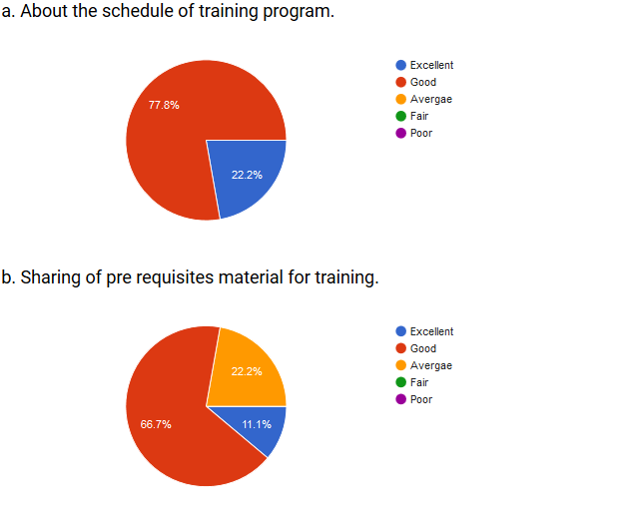
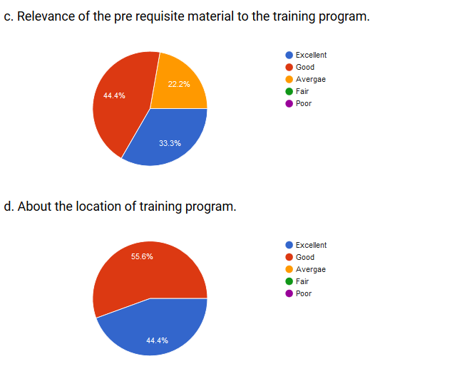

Schedule
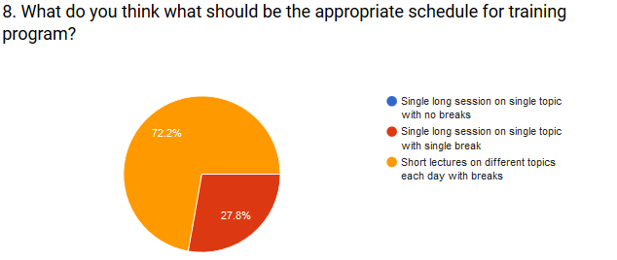

Teaching Methodology
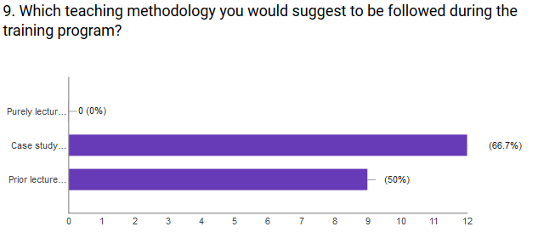

Learning Survey (Pre Training)
As a result of attending a training course, apart from subject specific what sort of new knowledge and skills do you expect to gain? (rank in order of your priority from 1-8)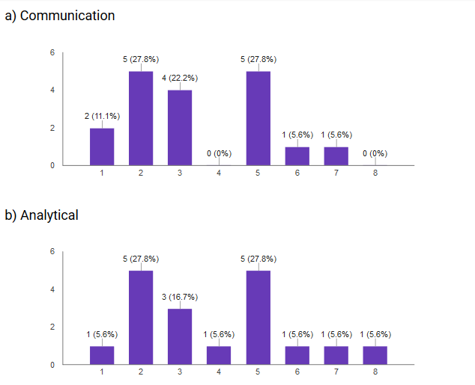 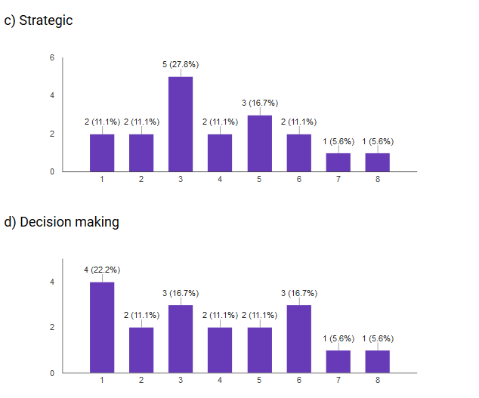

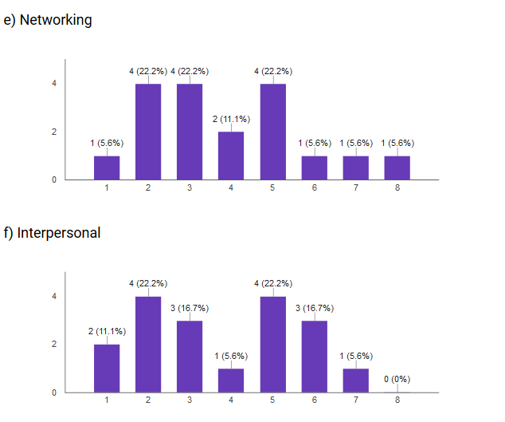
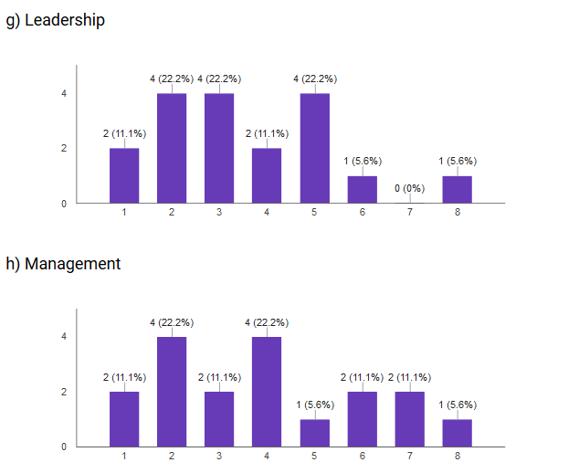

Reaction survey (Post-Training)

- Express your opinion about the attributes of training course you attended.

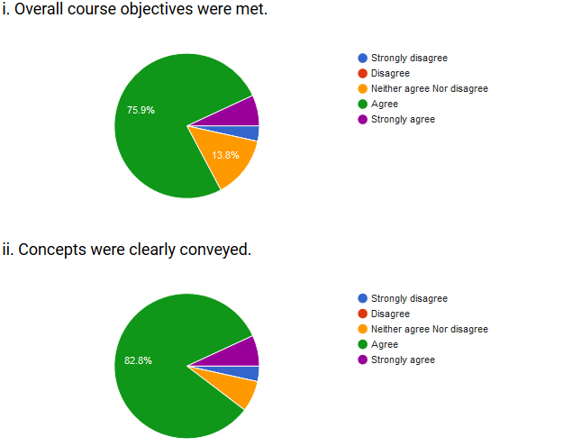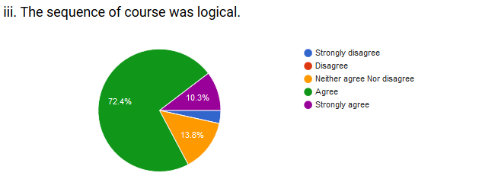

- Interaction
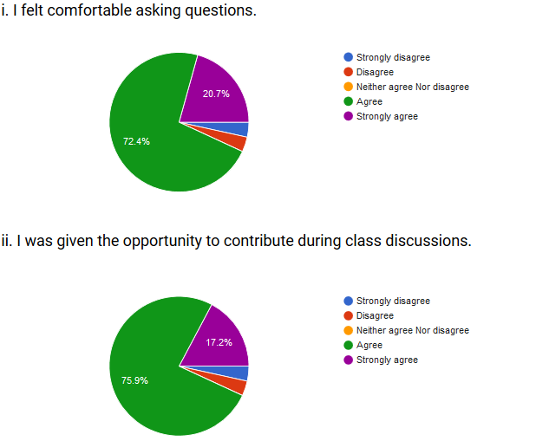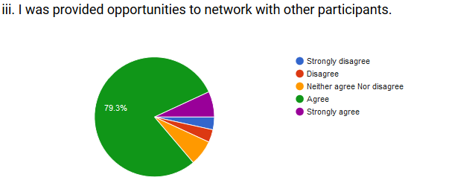

- Instructor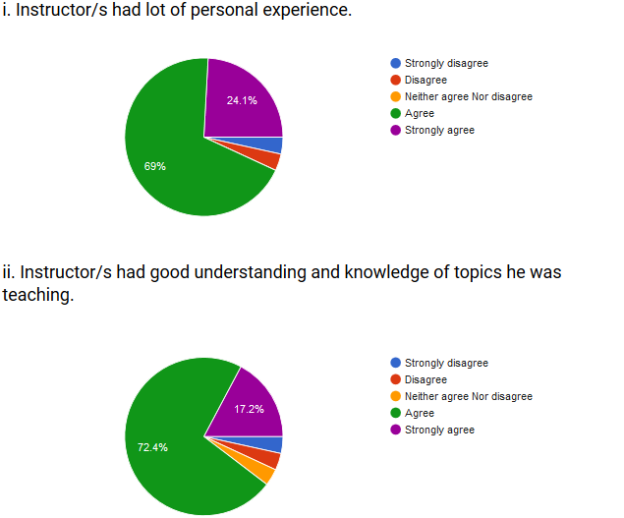
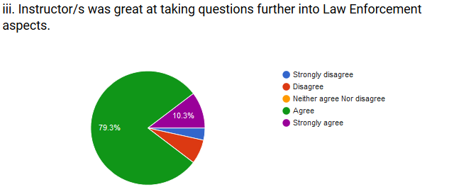

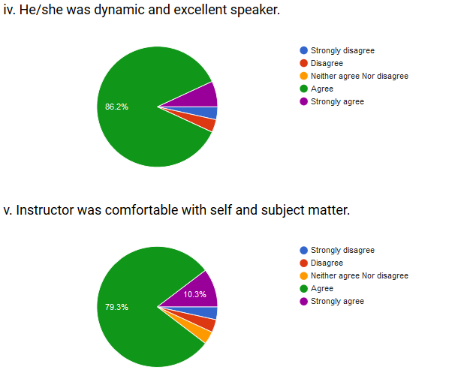

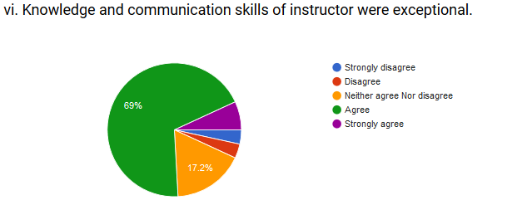

- Course content

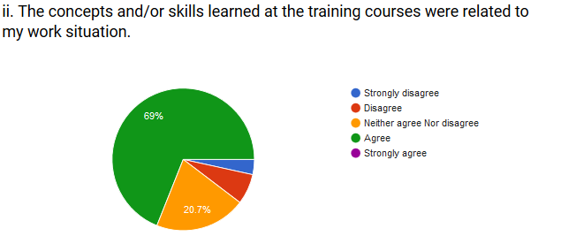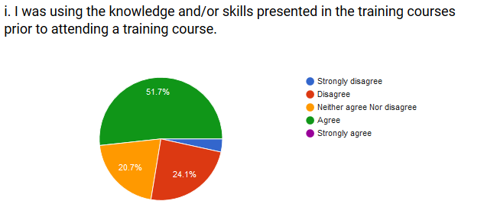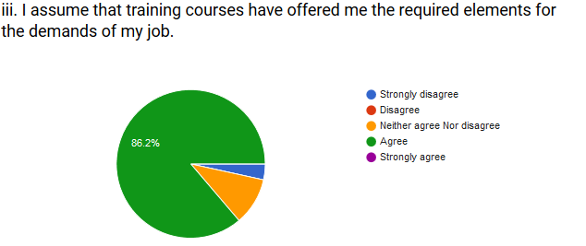
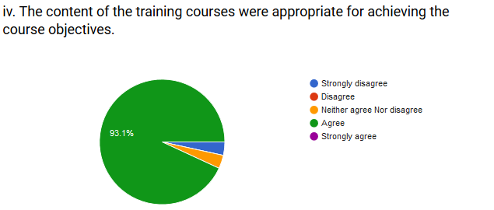

- Expectations of the training course

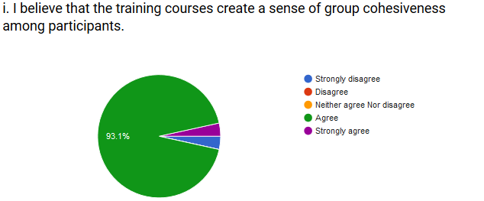
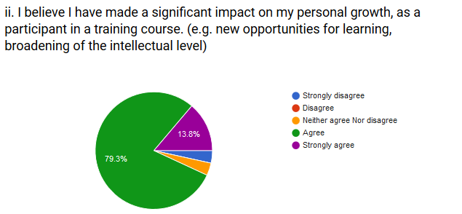
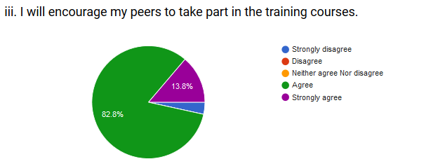
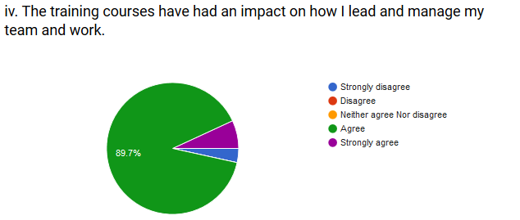

- Technical conditions

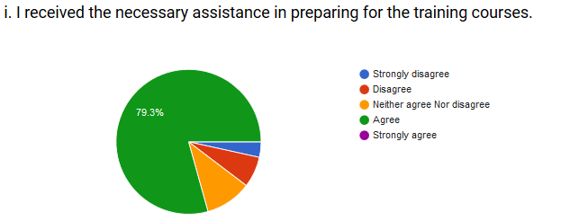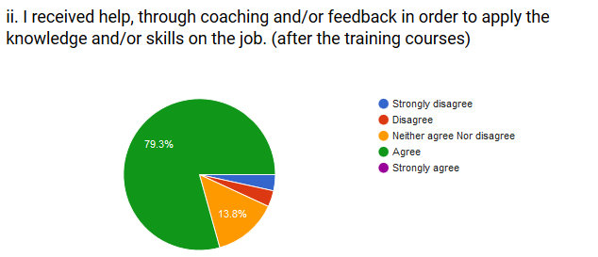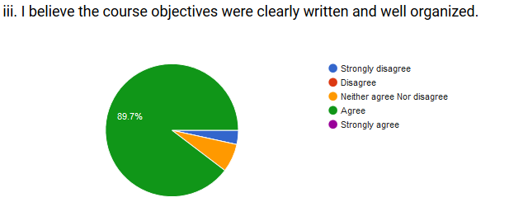
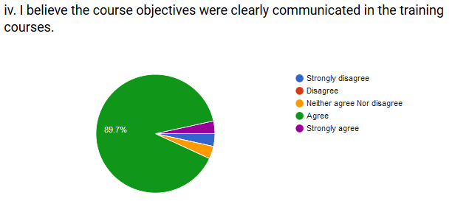

- Quality of the Training
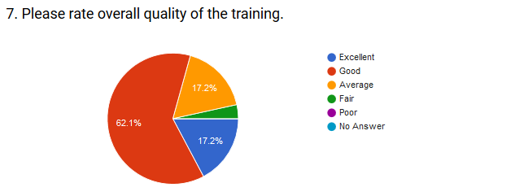

Learning survey (Post Training)
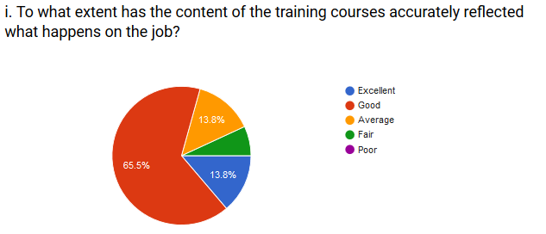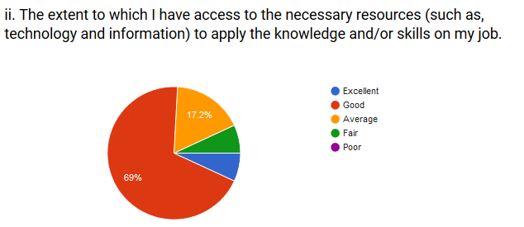
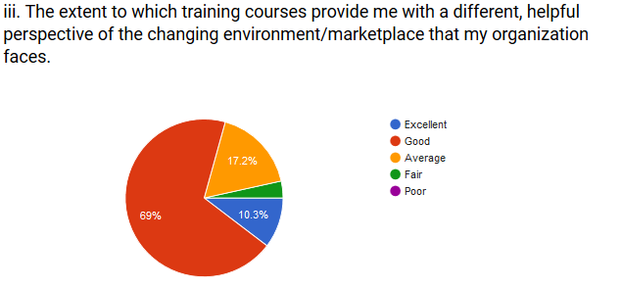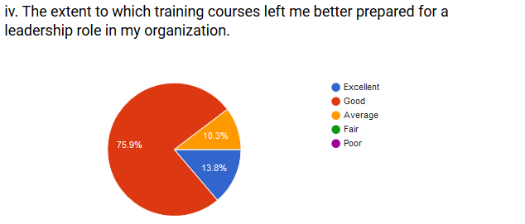

Activity Management System

Course: Training of Probationer Additional District & Sessions Judges/ Izafi Zilla Qazis
Topic: Alternative Dispute Resolution (ADR)
Resource Person: Barrister Asfandyar
Duration: 05 minutes
Total MCQs: 10
Average score: 88%
Details
S.No | Participants | Marks Obtained | Total Marks | Percentage (%)
1 | Arbab Aziz Ahmad | 10 | 10 | 100
2 | Mr. Bakht Alam | 10 | 10 | 100
3 | Mr. Jamal Shah Mahsood | 10 | 10 | 100
4 | Mr. Liaqat Ali | 10 | 10 | 100
5 | Mr. Muhammad Saeed Amjad | 10 | 10 | 100
6 | Mr. Muhammad Tahir Aurangzeb | 10 | 10 | 100
7 | Mr. Naveed-ur-Rahman | 10 | 10 | 100
8 | Mr. Zia-ur-Rahman | 10 | 10 | 100
9 | Mr. Adil Majeed Khan | 9 | 10 | 90
10 | Mr. Faheem Afzal Khan | 9 | 10 | 90
11 | Mr. Iftikhar Elahi | 9 | 10 | 90
12 | Mr. Kashif Dilawar | 9 | 10 | 90
13 | Mr. Muambar | 9 | 10 | 90
14 | Mr. Muhammad Khan | 9 | 10 | 90
15 | Mr. Muhammad Zaib Khan | 9 | 10 | 90
16 | Mr. Rahat Ullah | 9 | 10 | 90
17 | Mr. Rashid Ullah Kundi | 9 | 10 | 90
18 | Mr. Zia-ul-Haq | 9 | 10 | 90
19 | Syed Yasir Shabbir | 9 | 10 | 90
20 | Mr. Amjad Hussain | 8 | 10 | 80
21 | Mr. Wajid Ali Khan | 8 | 10 | 80
22 | Mian Mahmood | 7 | 10 | 70
23 | Mr. Said Badshah | 6 | 10 | 60
24 | Mr. Shakir Ullah Khan | 6 | 10 | 60
25 | Mr. Shaukat Ali | 6 | 10 | 60

Course: Training of Probationer Additional District & Sessions Judges/ Izafi Zilla Qazis
Topic: Illegal Dispossession Act
Resource Person: Mr. Mohammad Zeb Khan
Duration: 05 minutes
Total MCQs: 10
Average score: 92%
Details
S.No | Participants | Marks  Obtained | Total  Marks | Percentage  (%)
1 | Arbab Aziz Ahmad | 10 | 10 | 100
2 | Mr. Adil Majeed Khan | 10 | 10 | 100
3 | Mr. Faheem Afzal Khan | 10 | 10 | 100
4 | Mr. Muhammad Saeed Amjad | 10 | 10 | 100
5 | Mr. Muhammad Tahir Aurangzeb | 10 | 10 | 100
6 | Mr. Muhammad Zaib Khan | 10 | 10 | 100
7 | Mr. Naveed-ur-Rahman | 10 | 10 | 100
8 | Mr. Rashid Ullah Kundi | 10 | 10 | 100
9 | Mr. Zia-ul-Haq | 10 | 10 | 100
10 | Mr. Zia-ur-Rahman | 10 | 10 | 100
11 | Syed Yasir Shabbir | 10 | 10 | 100
12 | Mian Mahmood | 9 | 10 | 90
13 | Mr. Amjad Hussain | 9 | 10 | 90
14 | Mr. Bakht Alam | 9 | 10 | 90
15 | Mr. Iftikhar Elahi | 9 | 10 | 90
16 | Mr. Jamal Shah Mahsood | 9 | 10 | 90
17 | Mr. Kashif Dilawar | 9 | 10 | 90
18 | Mr. Rahat Ullah | 9 | 10 | 90
19 | Mr. Said Badshah | 9 | 10 | 90
20 | Mr. Shakir Ullah Khan | 9 | 10 | 90
21 | Mr. Shaukat Ali | 9 | 10 | 90
22 | Mr. Liaqat Ali | 8 | 10 | 80
23 | Mr. Muambar | 8 | 10 | 80
24 | Mr. Wajid Ali Khan | 8 | 10 | 80
25 | Mr. Muhammad Khan | 7 | 10 | 70

Course: Training of Probationer Additional District & Sessions Judges/ Izafi Zilla Qazis
Topic: Civil Appeal Review & Reference
Resource Person: Mr. Muhammad Masood Khan
Duration: 05 minutes
Total MCQs: 10
Average score: 52%
Details
S.No | Participants | Marks  Obtained | Total  Marks | Percentage  (%)
1 | Mian Mahmood | 7 | 10 | 70
2 | Mr. Kashif Dilawar | 7 | 10 | 70
3 | Mr. Muhammad Tahir Aurangzeb | 7 | 10 | 70
4 | Mr. Wajid Ali Khan | 7 | 10 | 70
5 | Arbab Aziz Ahmad | 6 | 10 | 60
6 | Mr. Muhammad Zaib Khan | 6 | 10 | 60
7 | Mr. Shakir Ullah Khan | 6 | 10 | 60
8 | Mr. Zia-ur-Rahman | 6 | 10 | 60
9 | Mr. Adil Majeed Khan | 5 | 10 | 50
10 | Mr. Bakht Alam | 5 | 10 | 50
11 | Mr. Iftikhar Elahi | 5 | 10 | 50
12 | Mr. Jamal Shah Mahsood | 5 | 10 | 50
13 | Mr. Liaqat Ali | 5 | 10 | 50
14 | Mr. Muhammad Saeed Amjad | 5 | 10 | 50
15 | Mr. Naveed-ur-Rahman | 5 | 10 | 50
16 | Mr. Said Badshah | 5 | 10 | 50
17 | Mr. Zia-ul-Haq | 5 | 10 | 50
18 | Syed Yasir Shabbir | 5 | 10 | 50
19 | Mr. Faheem Afzal Khan | 4 | 10 | 40
20 | Mr. Muambar | 4 | 10 | 40
21 | Mr. Muhammad Khan | 4 | 10 | 40
22 | Mr. Rahat Ullah | 4 | 10 | 40
23 | Mr. Shaukat Ali | 4 | 10 | 40
24 | Mr. Amjad Hussain | 3 | 10 | 30

Course: Training of Probationer Additional District & Sessions Judges/ Izafi Zilla Qazis
Topic: Court & Case Management
Resource Person: Khawaja Wajeeh ud din
Duration: 05 minutes
Total MCQs: 10
Average score: 92%
Details
S.No | Participants | Marks  Obtained | Total  Marks | Percentage  (%)
1 | Mr. Adil Majeed Khan | 10 | 10 | 100
2 | Mr. Amjad Hussain | 10 | 10 | 100
3 | Mr. Faheem Afzal Khan | 10 | 10 | 100
4 | Mr. Iftikhar Elahi | 10 | 10 | 100
5 | Mr. Muambar | 10 | 10 | 100
6 | Mr. Muhammad Khan | 10 | 10 | 100
7 | Mr. Muhammad Saeed Amjad | 10 | 10 | 100
8 | Mr. Muhammad Tahir Aurangzeb | 10 | 10 | 100
9 | Mr. Said Badshah | 10 | 10 | 100
10 | Syed Yasir Shabbir | 10 | 10 | 100
11 | Mian Mahmood | 9 | 10 | 90
12 | Mr. Bakht Alam | 9 | 10 | 90
13 | Mr. Jamal Shah Mahsood | 9 | 10 | 90
14 | Mr. Kashif Dilawar | 9 | 10 | 90
15 | Mr. Liaqat Ali | 9 | 10 | 90
16 | Mr. Muhammad Zaib Khan | 9 | 10 | 90
17 | Mr. Naveed-ur-Rahman | 9 | 10 | 90
18 | Mr. Rashid Ullah Kundi | 9 | 10 | 90
19 | Mr. Wajid Ali Khan | 9 | 10 | 90
20 | Mr. Zia-ul-Haq | 9 | 10 | 90
21 | Mr. Zia-ur-Rahman | 9 | 10 | 90
22 | Arbab Aziz Ahmad | 8 | 10 | 80
23 | Mr. Shakir Ullah Khan | 8 | 10 | 80
24 | Mr. Rahat Ullah | 7 | 10 | 70

Course: Training of Probationer Additional District & Sessions Judges/ Izafi Zilla Qazis
Topic: Jurisdiction of Civil Courts
Resource Person: Mr. Azeem Khan Afridi
Duration: 05 minutes
Total MCQs: 10
Average score: 97%
Details
S.No | Participants | Marks  Obtained | Total  Marks | Percentage  (%)
1 | Arbab Aziz Ahmad | 10 | 10 | 100
2 | Mr. Adil Majeed Khan | 10 | 10 | 100
3 | Mr. Amjad Hussain | 10 | 10 | 100
4 | Mr. Bakht Alam | 10 | 10 | 100
5 | Mr. Faheem Afzal Khan | 10 | 10 | 100
6 | Mr. Iftikhar Elahi | 10 | 10 | 100
7 | Mr. Jamal Shah Mahsood | 10 | 10 | 100
8 | Mr. Kashif Dilawar | 10 | 10 | 100
9 | Mr. Liaqat Ali | 10 | 10 | 100
10 | Mr. Muambar | 10 | 10 | 100
11 | Mr. Muhammad Zaib Khan | 10 | 10 | 100
12 | Mr. Rahat Ullah | 10 | 10 | 100
13 | Mr. Rashid Ullah Kundi | 10 | 10 | 100
14 | Mr. Said Badshah | 10 | 10 | 100
15 | Mr. Shakir Ullah Khan | 10 | 10 | 100
16 | Mr. Zia-ul-Haq | 10 | 10 | 100
17 | Syed Yasir Shabbir | 10 | 10 | 100
18 | Mian Mahmood | 9 | 10 | 90
19 | Mr. Muhammad Khan | 9 | 10 | 90
20 | Mr. Muhammad Saeed Amjad | 9 | 10 | 90
21 | Mr. Muhammad Tahir Aurangzeb | 9 | 10 | 90
22 | Mr. Naveed-ur-Rahman | 9 | 10 | 90
23 | Mr. Wajid Ali Khan | 9 | 10 | 90
24 | Mr. Zia-ur-Rahman | 9 | 10 | 90

Course: Training of Probationer Additional District & Sessions Judges/ Izafi Zilla Qazis
Topic: Court Fees --Suit/Appeal/Revision--Valuations
Duration: 05 minutes
Total MCQs: 10
Average score: 94%
Details
S.No | Participants | Marks  Obtained | Total  Marks | Percentage  (%)
1 | Arbab Aziz Ahmad | 10 | 10 | 100
2 | Mian Mahmood | 10 | 10 | 100
3 | Mr. Amjad Hussain | 10 | 10 | 100
4 | Mr. Faheem Afzal Khan | 10 | 10 | 100
5 | Mr. Jamal Shah Mahsood | 10 | 10 | 100
6 | Mr. Kashif Dilawar | 10 | 10 | 100
7 | Mr. Muambar | 10 | 10 | 100
8 | Mr. Muhammad Saeed Amjad | 10 | 10 | 100
9 | Mr. Muhammad Zaib Khan | 10 | 10 | 100
10 | Mr. Said Badshah | 10 | 10 | 100
11 | Mr. Shakir Ullah Khan | 10 | 10 | 100
12 | Mr. Zia-ul-Haq | 10 | 10 | 100
13 | Syed Yasir Shabbir | 10 | 10 | 100
14 | Mr. Bakht Alam | 9 | 10 | 90
15 | Mr. Iftikhar Elahi | 9 | 10 | 90
16 | Mr. Liaqat Ali | 9 | 10 | 90
17 | Mr. Muhammad Khan | 9 | 10 | 90
18 | Mr. Muhammad Tahir Aurangzeb | 9 | 10 | 90
19 | Mr. Naveed-ur-Rahman | 9 | 10 | 90
20 | Mr. Rahat Ullah | 9 | 10 | 90
21 | Mr. Rashid Ullah Kundi | 9 | 10 | 90
22 | Mr. Wajid Ali Khan | 9 | 10 | 90
23 | Mr. Adil Majeed Khan | 8 | 10 | 80
24 | Mr. Zia-ur-Rahman | 8 | 10 | 80
25 | Mr. Shaukat Ali | 7 | 10 | 70

Course: Training of Probationer Additional District & Sessions Judges/ Izafi Zilla Qazis
Topic: Tribunal presided by ADJs
Resource Person: Mr. Amjad Majeed
Duration: 05 minutes
Total MCQs: 10
Average score: 82%
Details
S.No | Participants | Marks  Obtained | Total  Marks | Percentage  (%)
1 | Arbab Aziz Ahmad | 10 | 10 | 100
2 | Mr. Iftikhar Elahi | 10 | 10 | 100
3 | Mr. Jamal Shah Mahsood | 10 | 10 | 100
4 | Mr. Muhammad Tahir Aurangzeb | 10 | 10 | 100
5 | Mr. Rashid Ullah Kundi | 10 | 10 | 100
6 | Mr. Shaukat Ali | 10 | 10 | 100
7 | Mian Mahmood | 9 | 10 | 90
8 | Mr. Faheem Afzal Khan | 9 | 10 | 90
9 | Mr. Liaqat Ali | 9 | 10 | 90
10 | Mr. Muhammad Saeed Amjad | 9 | 10 | 90
11 | Mr. Rahat Ullah | 9 | 10 | 90
12 | Mr. Zia-ur-Rahman | 9 | 10 | 90
13 | Mr. Adil Majeed Khan | 8 | 10 | 80
14 | Mr. Kashif Dilawar | 8 | 10 | 80
15 | Mr. Muhammad Zaib Khan | 8 | 10 | 80
16 | Mr. Naveed-ur-Rahman | 8 | 10 | 80
17 | Mr. Shakir Ullah Khan | 8 | 10 | 80
18 | Syed Yasir Shabbir | 8 | 10 | 80
19 | Mr. Wajid Ali Khan | 7 | 10 | 70
20 | Mr. Zia-ul-Haq | 7 | 10 | 70
21 | Mr. Amjad Hussain | 6 | 10 | 60
22 | Mr. Muambar | 6 | 10 | 60
23 | Mr. Muhammad Khan | 6 | 10 | 60
24 | Mr. Bakht Alam | 5 | 10 | 50
25 | Mr. Said Badshah | 5 | 10 | 50

Course: Training of Probationer Additional District & Sessions Judges/ Izafi Zilla Qazis
Topic: Office Management Skills
Resource Person: Mr. Abid Majeed
Duration: 05 minutes
Total MCQs: 10
Average score: 77%
Details
S.No | Participants | Marks  Obtained | Total  Marks | Percentage  (%)
1 | Mr. Iftikhar Elahi | 10 | 10 | 100
2 | Mr. Kashif Dilawar | 10 | 10 | 100
3 | Mr. Muhammad Khan | 10 | 10 | 100
4 | Mr. Muhammad Tahir Aurangzeb | 10 | 10 | 100
5 | Mr. Rashid Ullah Kundi | 10 | 10 | 100
6 | Arbab Aziz Ahmad | 9 | 10 | 90
7 | Mian Mahmood | 9 | 10 | 90
8 | Mr. Muhammad Saeed Amjad | 9 | 10 | 90
9 | Mr. Muhammad Zaib Khan | 9 | 10 | 90
10 | Mr. Rahat Ullah | 9 | 10 | 90
11 | Mr. Shaukat Ali | 9 | 10 | 90
12 | Mr. Wajid Ali Khan | 9 | 10 | 90
13 | Mr. Said Badshah | 8 | 10 | 80
14 | Mr. Shakir Ullah Khan | 8 | 10 | 80
15 | Mr. Bakht Alam | 7 | 10 | 70
16 | Mr. Faheem Afzal Khan | 7 | 10 | 70
17 | Mr. Liaqat Ali | 7 | 10 | 70
18 | Mr. Naveed-ur-Rahman | 7 | 10 | 70
19 | Syed Yasir Shabbir | 7 | 10 | 70
20 | Mr. Muambar | 6 | 10 | 60
21 | Mr. Zia-ur-Rahman | 6 | 10 | 60
22 | Mr. Amjad Hussain | 5 | 10 | 50
23 | Mr. Jamal Shah Mahsood | 5 | 10 | 50
24 | Mr. Adil Majeed Khan | 4 | 10 | 40
25 | Mr. Zia-ul-Haq | 3 | 10 | 30

Annexure

Schedule of Activities
Monday (21st March 2016)
S# |  | Topic |  |  | Resource Person | Duration
 |  | Recitation of Holy Quran & Sermon |  |  |  | 08:30 - 09:00
1 |  | Civil Jurisdiction -- Original & Appellate  - Specific Relief Act  - Transfer of Property Act  - KPK Pre-emption Act |  |  | Barrister Babar Shahzad | 09:00 - 10:30
AMS Evaluation
Tea break -- 10:30 - 11:00
2 | Alternate Dispute Resolution (ADR) |  |  |  | Barrister Asfandyar | 11:00 - 12:30
AMS Evaluation
Launch & Prayer break 12:30 - 01:30
 |  | High Court Rules & Order and District Courts – study Circle |  |  | Ms. Hussan Bano | 01:30 - 03:00
AMS Evaluation
Tuesday (22nd March 2016)
S# |  | Topic |  |  | Resource Person | Duration
 |  | Recitation of Holy Quran & Sermon |  |  |  | 08:30 - 09:00
3 |  | Sessions Trail --  - Misc matters  - Criminal Revisions |  |  | Mr. Rajab Ali khan | 09:00 - 10:30
AMS Evaluation
Tea break -- 10:30 - 11:00
4 |  | Civil Appeal Review & Reference  - Concepts and interlocutory orders |  |  | Mr. Masood khan | 11:00 - 12:30
AMS Evaluation
Launch & Prayer break 12:30 - 01:30
5 |  | Summary Trial (Civil) |  |  | Mr. Sohail Shiraz Noor Sani | 01:30 - 03:00
AMS Evaluation
Thursday (24th March 2016)
S# |  | Topic |  |  | Resource Person | Duration
 |  | Recitation of Holy Quran & Sermon |  |  |  | 08:30 - 09:00
 |  | Judicial Estacode -- Study Circle |  |  | Mrs. Sofia Waqar Khattak | 09:00 - 10:30
Tea break -- 10:30 - 11:00
6 |  | Family Court; Procedures (Overview) |  |  | Ms. Nusrat Yasmeen | 11:00 - 12:30
AMS Evaluation
Launch & Prayer break 12:30 - 01:30
7 |  | Judicial Ethics & Code of Conduct --  - Judicial Conduct & Behavior  - Inside & outside Court  - With Bar, Staff, litigants, Public & Officers/ Officials of other Departments |  | Barrister Babar Shehzad |  | 01:30 - 03:00
AMS Evaluation
Friday (25th March 2016)
S# |  | Topic |  |  | Resource Person | Duration
 |  | Recitation of Holy Quran & Sermon |  |  |  | 08:30 - 09:00
8 |  | Ethics ---  Patience & Tolerance |  |  | Mr. Hasan Farooq | 9:00 - 10:30
Study Tour
Departure at 10:30
9 |  | Visit of Police Station East Cantt Peshawar  Working or Revenue Department |  |  | Mr. Muhammad Humayan (Girdawar) | 10:30 - 11:30
 |  |  |  |  | Mr. Muhammad Humayan (Girdawar) | 11:30 - 02:00
 |  | Launch & Prayer
Saturday (26th March 2016)
S# |  | Topic |  |  | Resource Person | Duration
 |  | Recitation of Holy Quran & Sermon |  |  |  | 08:30 - 09:00
10 |  | Human Rights -- Social & Economic dimensions of Judicial Decision making ---  - National economy and judicial system relationship  - Facilitating access to justice to down trodden  - Provision of justice at State expense  (Extension Lecture) |  |  | Mr. Abdullah, Ex. CS | 09:00 - 10:30
AMS Evaluation
Tea break -- 10:30 - 11:00
11 |  | Civil Revisions |  |  | Malik Mujtaba Ahmad | 11:00 - 12:30
AMS Evaluation
Launch & Prayer break 12:30 - 01:30
12 |  | Jurisdiction of Civil Courts |  |  | Mr. Azim Khan Afridi | 01:30 - 03:00
AMS Evaluation
Monday (28th March 2016)
S# |  | Topic |  |  | Resource Person | Duration
 |  | Recitation of Holy Quran & Sermon |  |  |  | 08:30 - 09:00
13 |  | Court Fees -- Suit/Appeal/Revision -- Valuations |  |  | Mr. Zakir tareen Adv. | 09:00 - 10:30
AMS Evaluation
Tea break -- 10:30 - 11:00
14 |  | Justice of Peace |  |  | Mr. Ihsan Mehsud | 11:00 - 12:30
AMS Evaluation
Launch & Prayer break 12:30 - 01:30
15 |  | Office Management Skills -- Theory  - HR management  - Job analysis & evaluation  - Forms of Official communication  - handling of official papers  - Noting and drafting skills  - Correspondence with Superior Courts & other Departments  - Communication & presentation skills  - Interpersonal  - Effective writing |  |  | Mr. Abid Majeed | 01:30 - 03:00
AMS Evaluation
Tuesday (29th March 2016)
S# |  | Topic |  |  | Resource Person | Duration
 |  | Recitation of Holy Quran & Sermon |  |  |  | 08:30 - 09:00
16 |  | Court & Case management -  - Sensitizing on Court & case management  - Skills in court & case management  - International best practices  - Important tools  - Case Flow management |  |  | Khawaja Wajeeh ud Din | 09:00 - 10:30
AMS Evaluation
Tea break -- 10:30 - 11:00
17 |  | Probation/ Parole |  |  | Naimatullah Khan | 11:00 - 12:30
Launch & Prayer break 12:30 - 01:30
18 |  |  |  |  | Mr. Fakhar Zaman | 01:30 - 03:00
Wednesday (30th March 2016)
 |  | Recitation of the Holy Quran |  |  |  | 08:30 - 08:35
19 |  | Session Trial -- Sentencing & mitigating circumstances |  |  | Mr. Ishtiaq Ibrahim | 08:35 - 10:00
AMS Evaluation
Tea break 10:05 - 10:30
20 |  | Court & Case Management - Practical |  |  | Khawaja Wajihuddin | 10.30 - 12:00
Lunch Break 12:30 - 01:30
21 |  | Tribunal presided by ADJs -  - Anti Encroachment laws  - Elections Laws  - Others |  |  | Mr. Amjad Makhdoom | 01:30 - 03:00
AMS Evaluation
Thursday (31st March 2016)
 |  | Recitation of the Holy Quran |  |  |  | 08:30 - 08:35
22 |  | Depip |  |  | Mr. Lal Shad | 08:35 - 10:05
Tea break 10:05 - 10:30
23 |  | Medical Jurisprudence |  |  | Dr. Hakeem Afridi | 10:30 - 12:00
AMS Evaluation
Launch & Prayer break 12:00 - 01:30
24 |  | Charge – Practical Exercise |  |  | Mr. Fakhar Zaman | 01:30 - 03:00
 |  | AMS Evaluation
Friday (1st April 2016)
 |  | Recitation of the Holy Quran |  |  |  | 08:30 - 08:35
5 |  | Assignment Presentations |  |  | Panel of Evaluators | 08:35 - 10:05
Tea break 10:05 - 10:30
 |  | Assignment Presentations |  |  | Panel of Evaluators | 10:30 - 12:00
 |  | Lunch & Prayer
Saturday (2nd April 2016)
Recitation of the Holy Quran |  |  |  |  |  | 09:00-9:05
25 |  |  | Ethics ---  - Patience & Tolerance |  | Mr. Hasan Farooq | 09:05-10:35
Tea break 10:35-11:00
26 |  |  | IT Skills (Theory + Practical) |  | Mr. Zulfiqar | 11:00-12:30
Post Evaluation.
Concluding Ceremony
1.1 Arrival of Hon'able the Chief Justice
1.2 CR Remarks
1.3 Concluding Address of DG KPJA
1.4 Certificate distribution
Launch

List of Participants
S.No | Name of ADJs | Designation | Posted At
1 | Mr. Adil Majeed Khan | Additional District & Sessions Judge | Abbotabad
2 | Mr. Shakir ullah Khan | Additional District & Sessions Judge | Peshawar
3 | Mr. Arbab Aziz Ahmad | Additional District & Sessions Judge | D.I Khan
4 | Syed Yasir Shabbir | Additional District & Sessions Judge | Peshawar
5 | Mr. Zia ur Rahman | Additional District & Sessions Judge | Lakki Marwat
6 | Mr. Rashid Ullah Kundi | Additional District & Sessions Judge | Bannu
7 | Mr. Jamal Shah Mahsood | Additional District & Sessions Judge | Kohat
8 | Mr. Muhammad Saeed Amjad | Additional District & Sessions Judge | Lakki Marwat
9 | Mr. Muambar | Additional District & Sessions Judge | Peshawar
10 | Mr. Naveed ur Rahman | Additional District & Sessions Judge | Abbotabad
11 | Mr. Said Badshah | Additional District & Sessions Judge | Abbotabad
12 | Mr. Shaukat Ali | Additional District & Sessions Judge | Haripur
13 | Mr. Zia ul Haq | Additional District & Sessions Judge | Manshera
14 | Mr. Bakht Alam | Additional District & Sessions Judge | Haripur
15 | Mr. Wajid Ali | Additional District & Sessions Judge | Batagram
16 | Mr. Rahat ullah | Additional District & Sessions Judge | Kohat
17 | Mr. Amjad Hussain | Additional District & Sessions Judge | Haripur
18 | Mr. Muhammad Tahir Auranzeb | Additional District & Sessions Judge | Dir Upper
19 | Mr. Mohammad Khan | Additional District & Sessions Judge | Mardan
20 | Mr. Iftikhar Elahi | Additional District & Sessions Judge | Malakand
21 | Mr. Liaqat Ali | Additional District & Sessions Judge | Hangu
22 | Mr. Kashif Dilawar | Additional District & Sessions Judge | Mardan
23 | Mr.Muhammad Zaib Khan | Additional District & Sessions Judge | Swat
24 | Mr. Faheem Afzal Khan | Additional District & Sessions Judge | Kohat
25 | Mian Mahmood | Additional District & Sessions Judge | Manshera

Group Photo
